Python Robot Automation Framework

Create a new Project and add necessary libraries in Python Interpreter

Create a new package

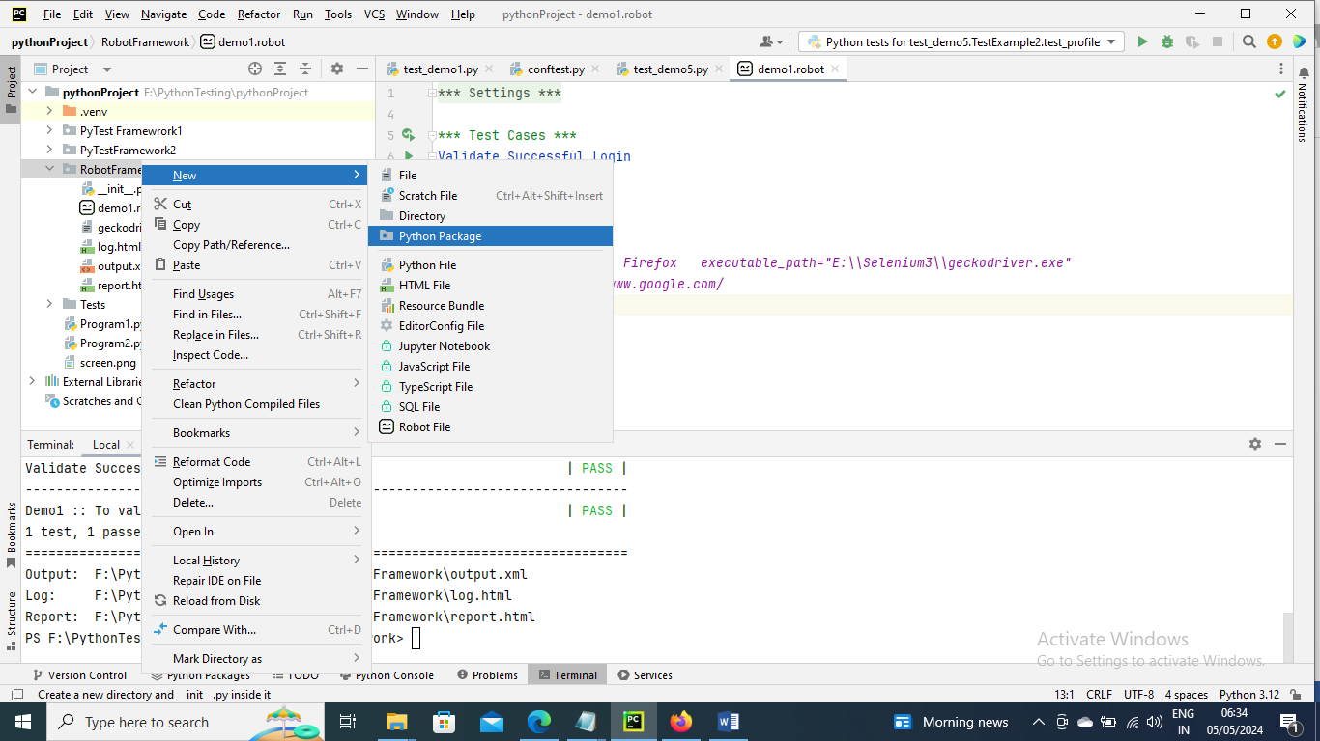

Create a new file and name with .robot extension for example demo1.robot

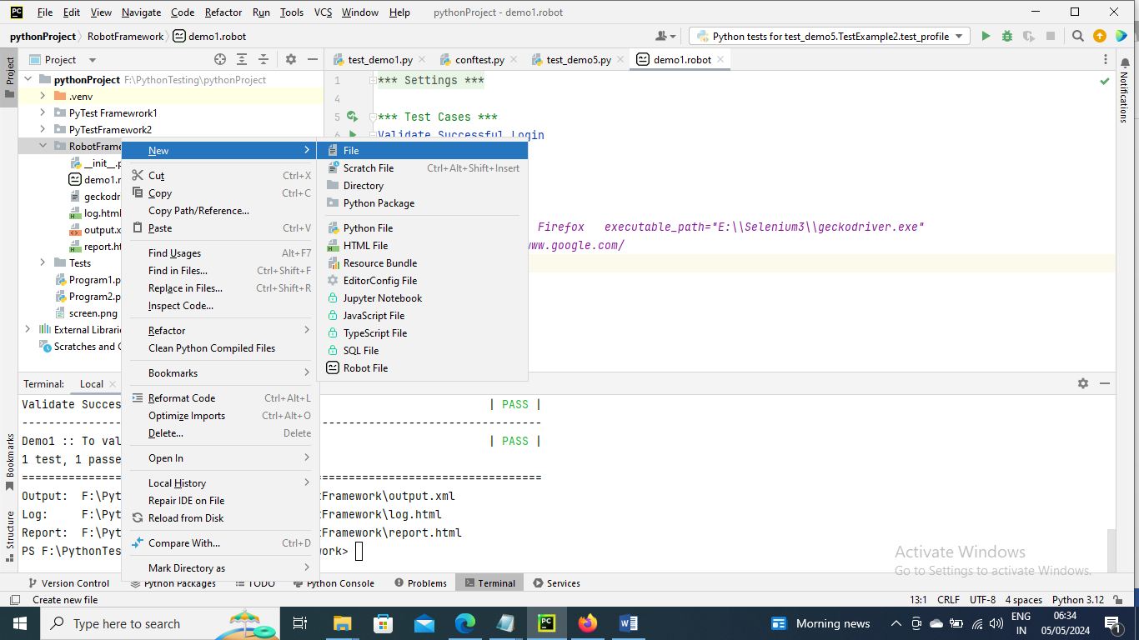

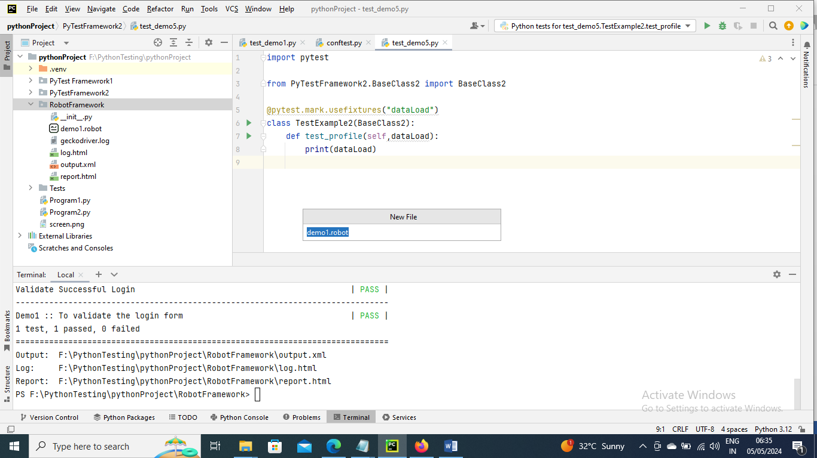

------------------

Below is a sample program to open a google page

Here documentation mean the heading of the program what was being done

Here “open the browser” is a keyword of the test case “Validate Successful Login”

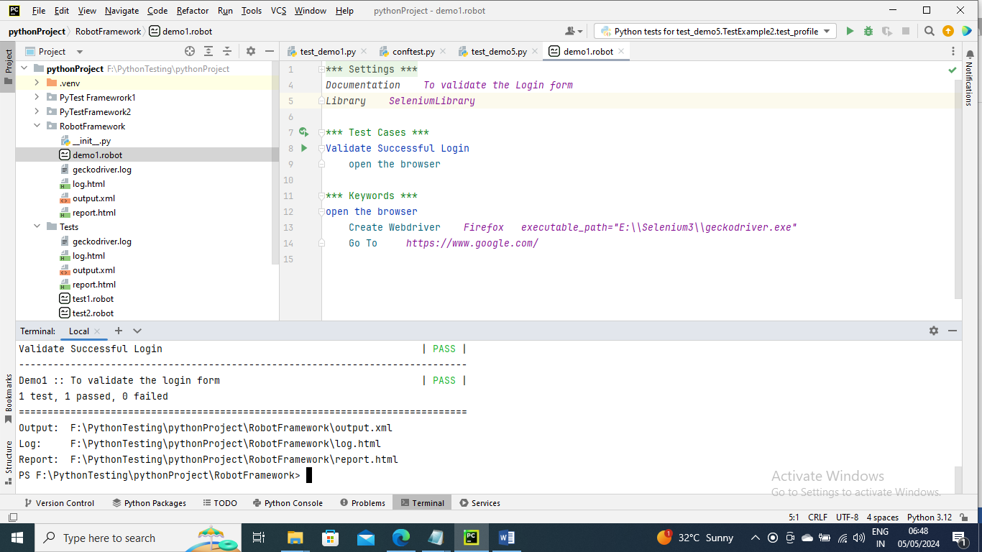

Now to run this program go to terminal in python and go to console tab and go to the package directory by give cd entire directory name

Run the command robot program_name.robot

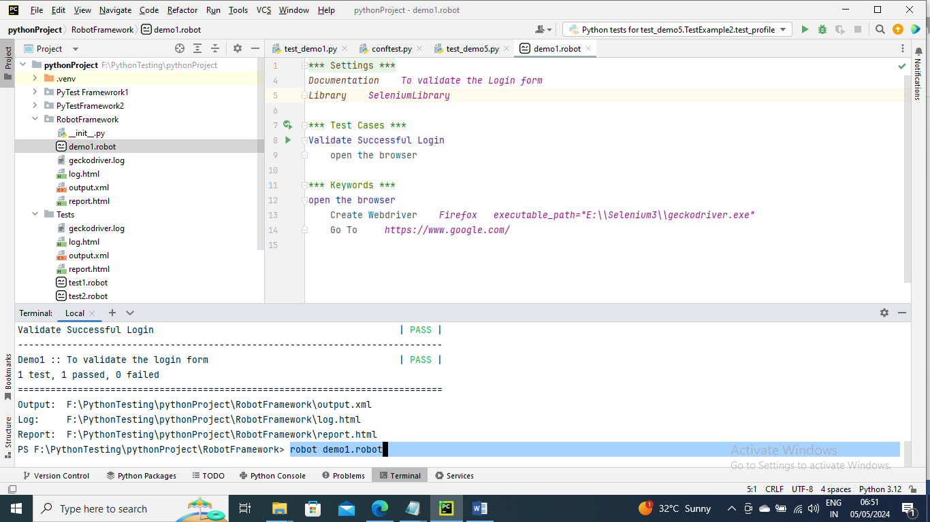

----------------

In the below program we are trying to login and if login is error we are waiting until that locator is available (since we are using it multiple times I have created a variable for it) then it will verify the error message with given “Incorrect username/password” and if it matches it gets passed

And to close the browser we gave Test Teardown which gets executed at last so we gave to “close browser” which will close the browser

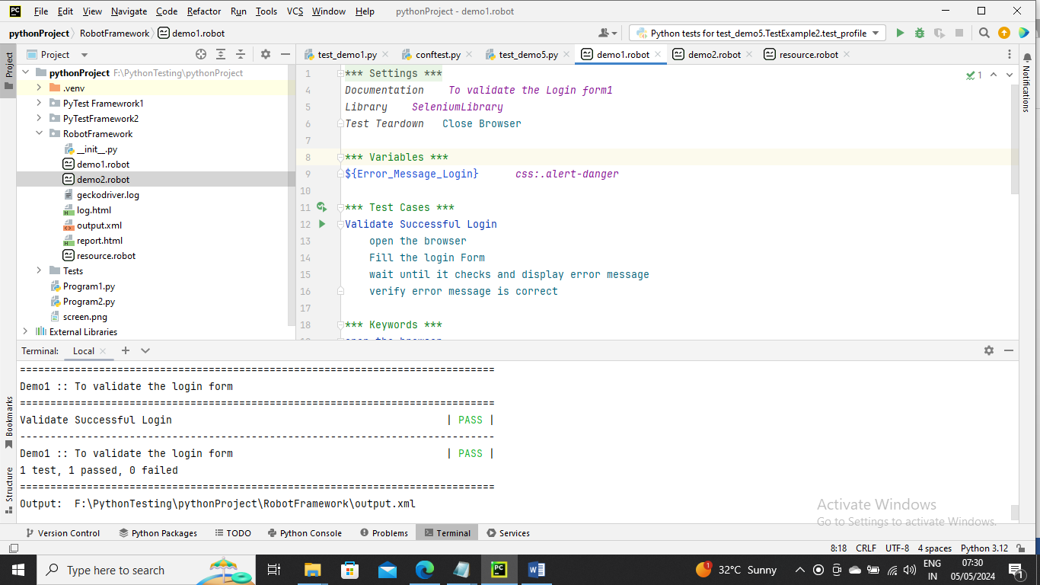

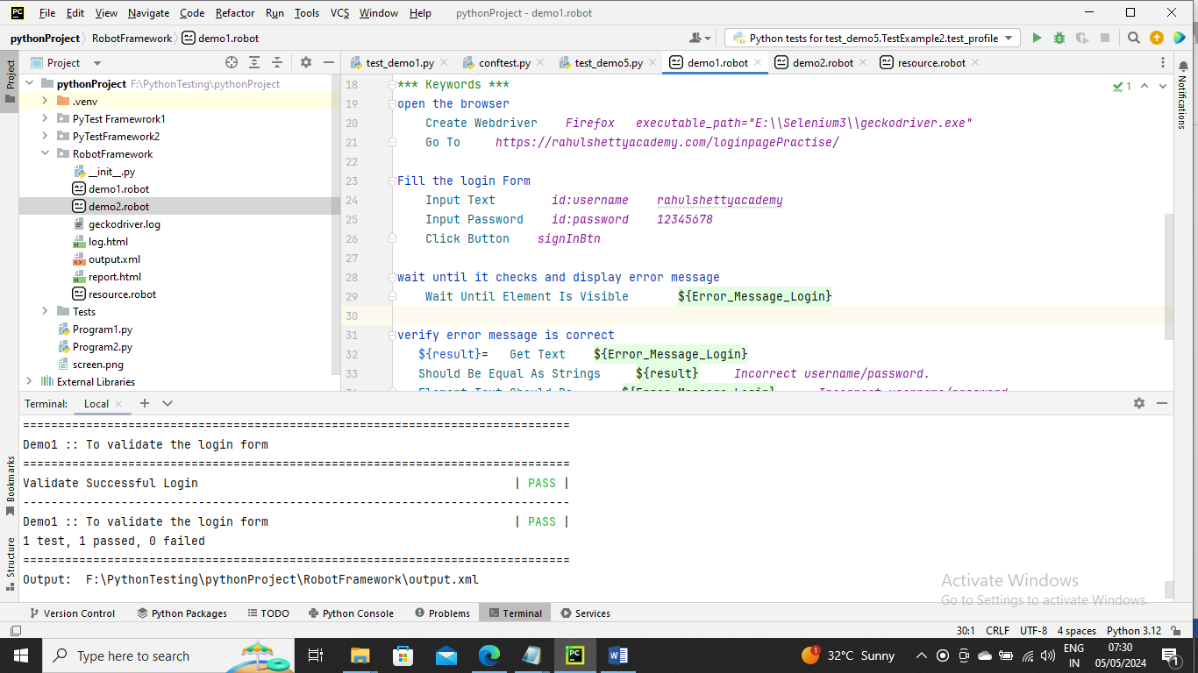

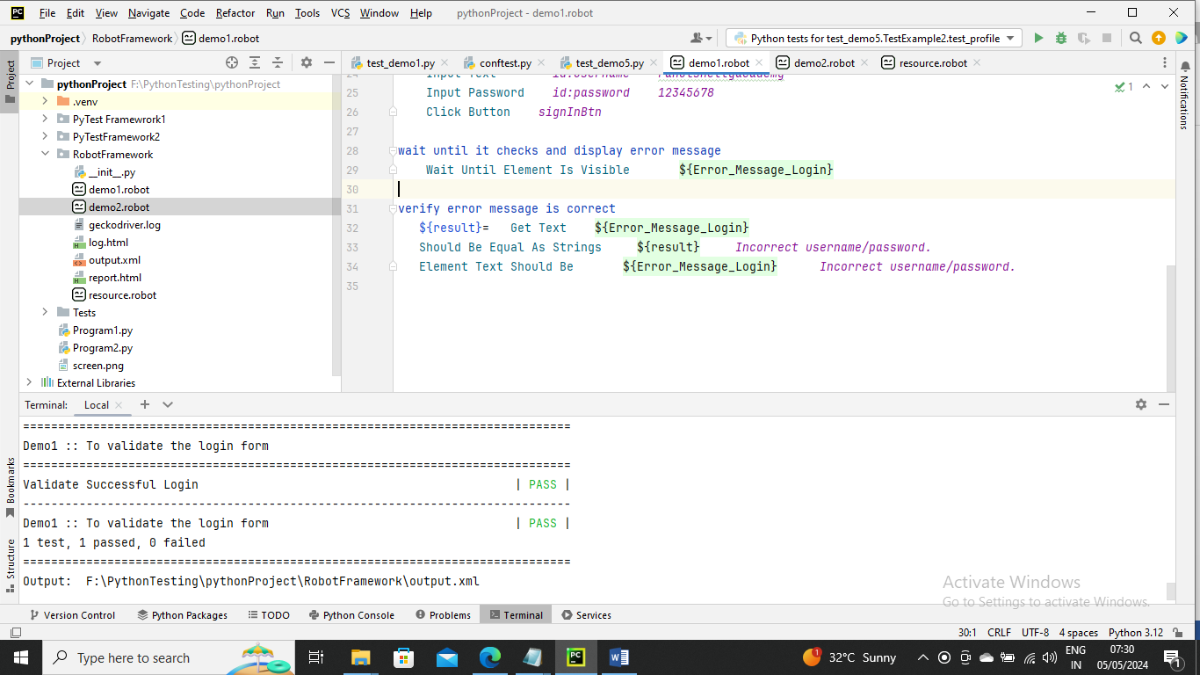

Run the command and below is output

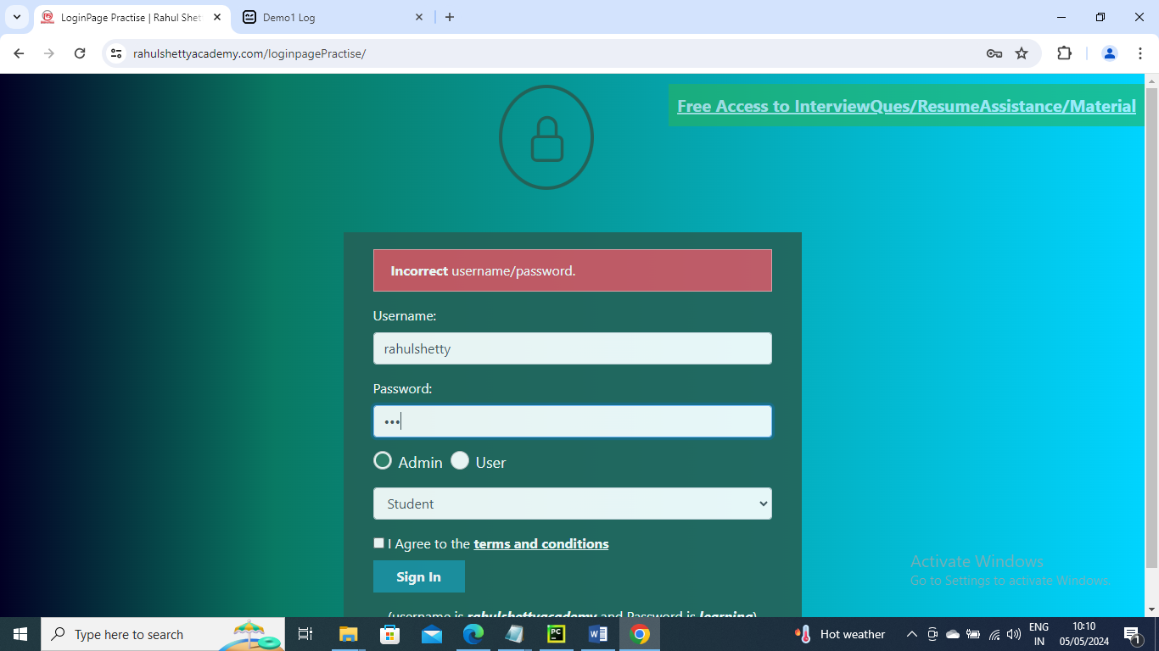

-----------------------------

Since open the browser Login page is a very common and first step we can have that in Test Setup i.e. Test Setup gets executed first it’s like BeforeClass kind off so you can remove it from test case and add it in Settings section

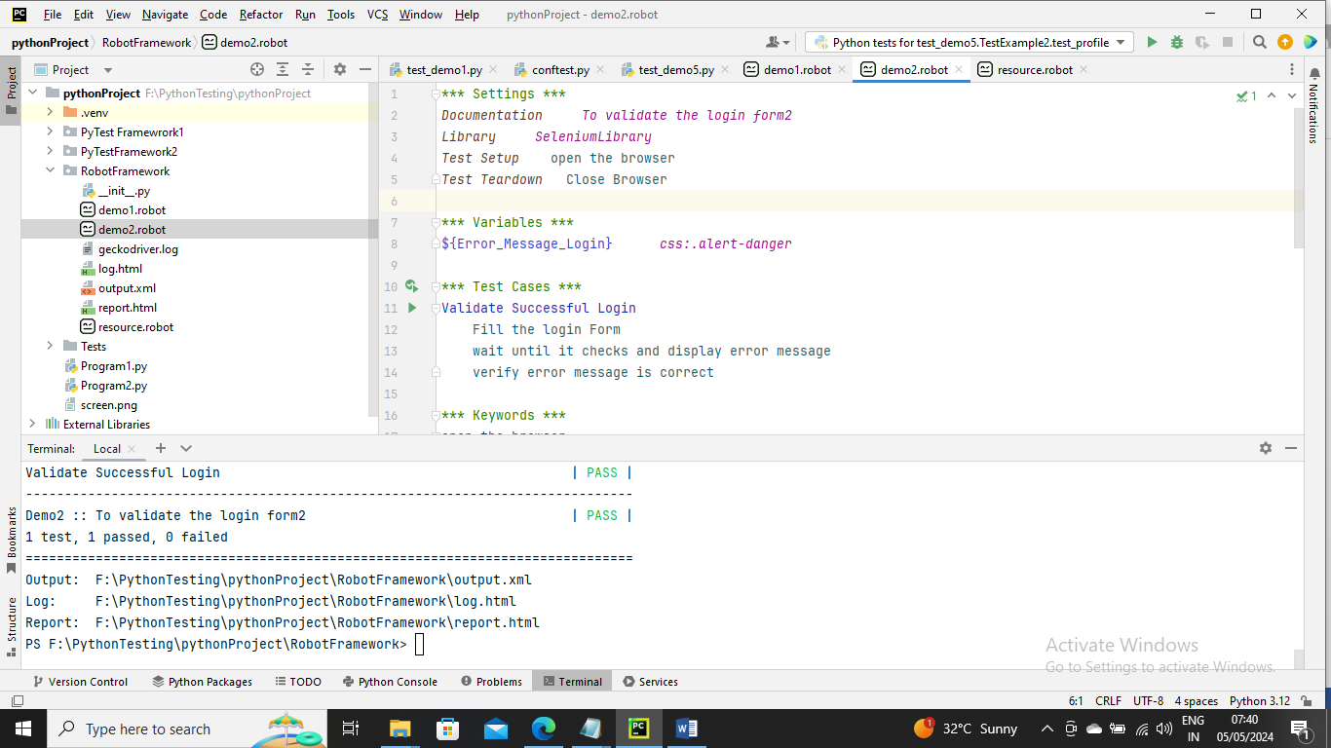

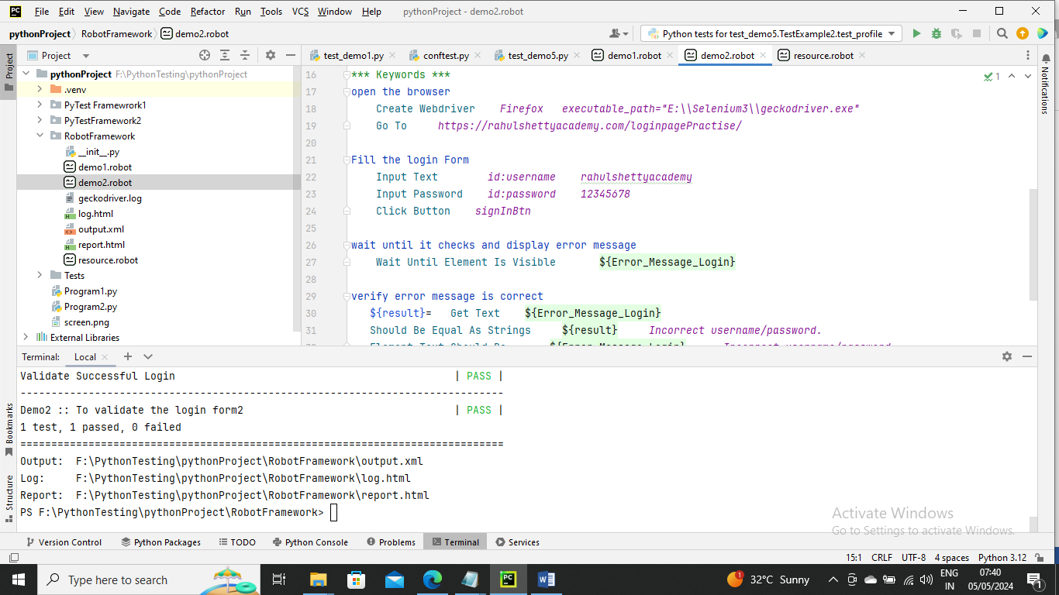

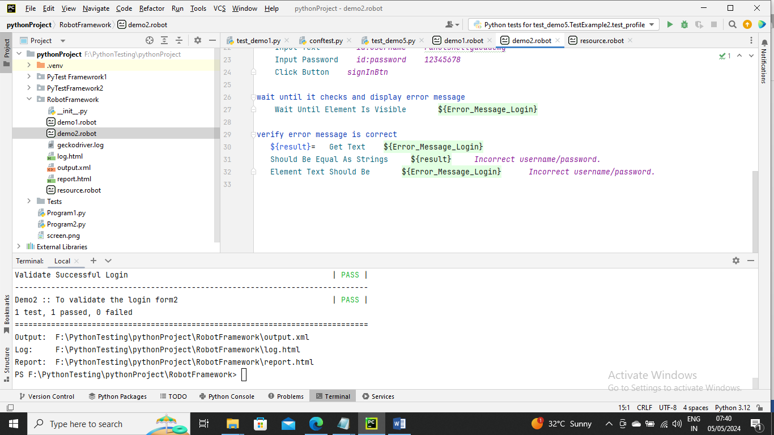

-----------------------

Here we see many things are common like the open the browser, closing the browser and user login credentials I can keep in resource file so that in case other program wants to use then it can access this

Below is the resource file where re-usable data is written

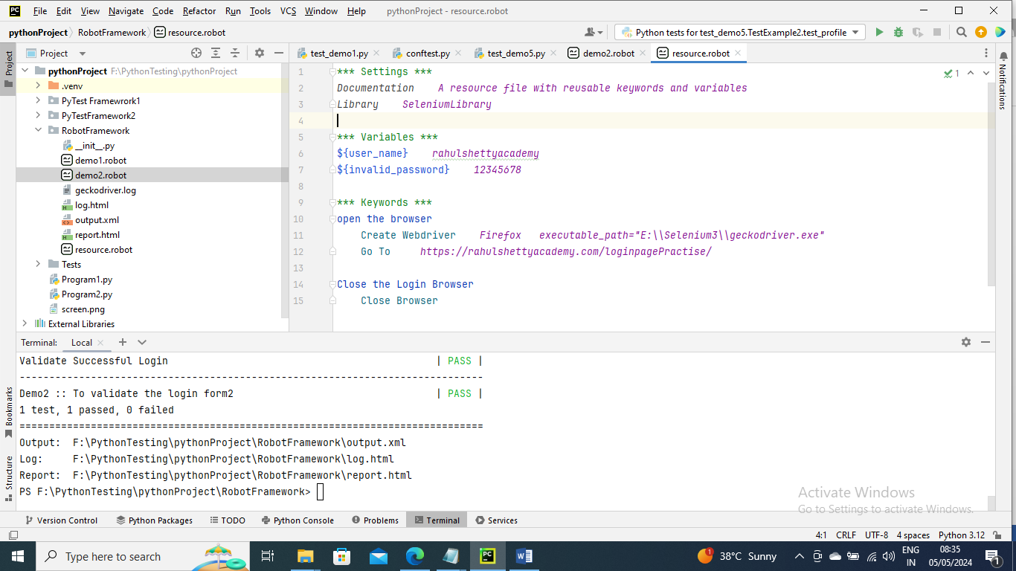

Below is the file that is using reusable data

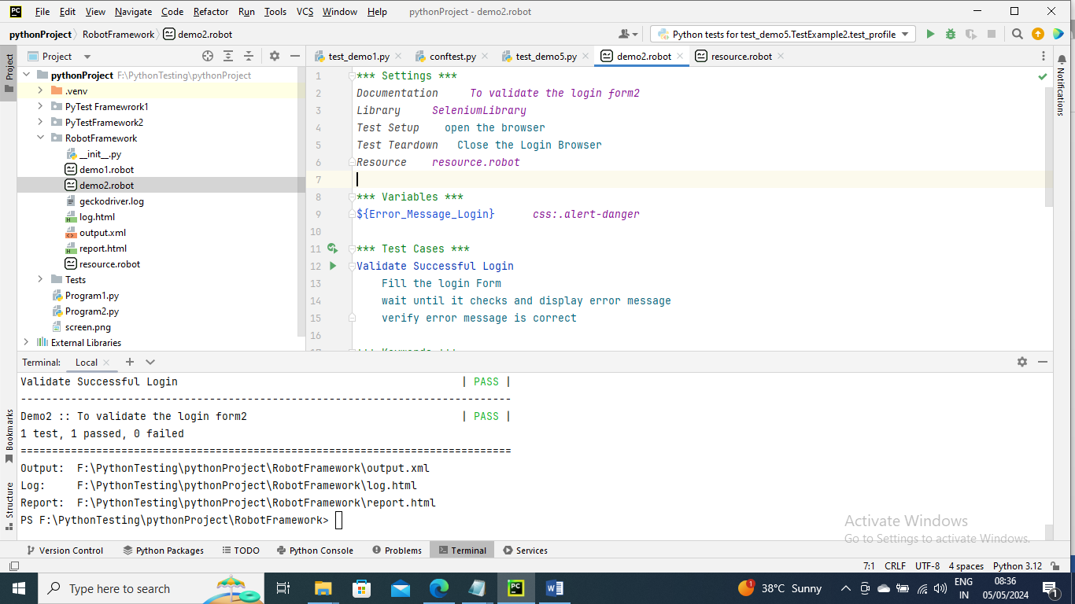

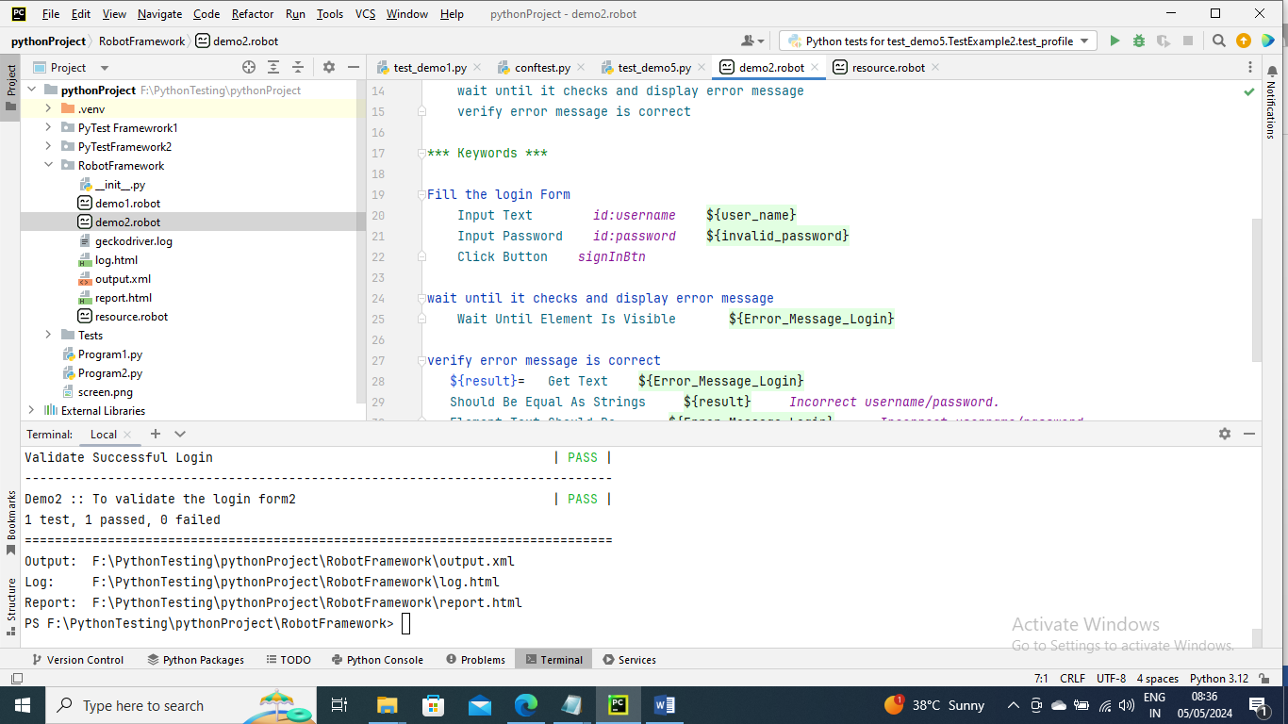

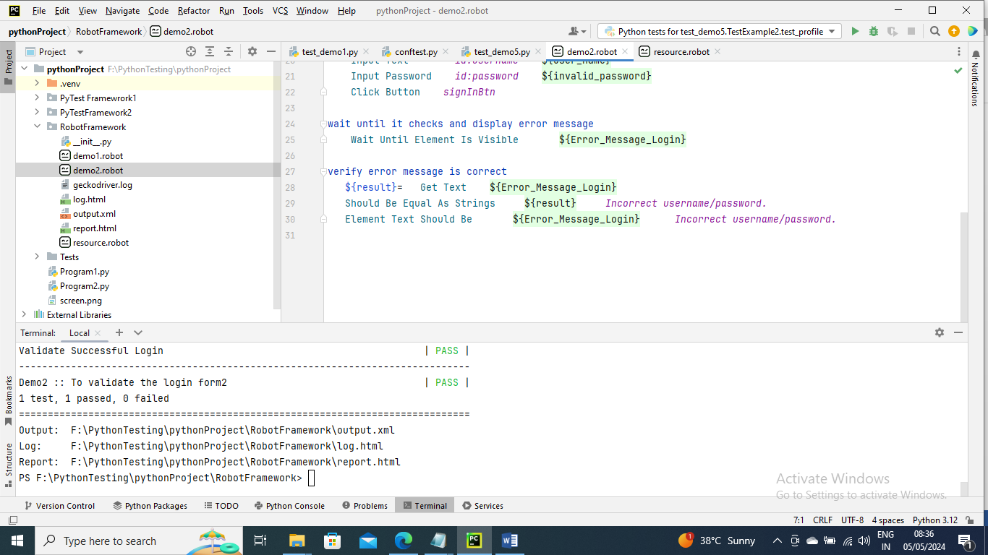

Run the program

-----------------

Below is an example of how to pass arguments to a Test Case

Resource file is not changed

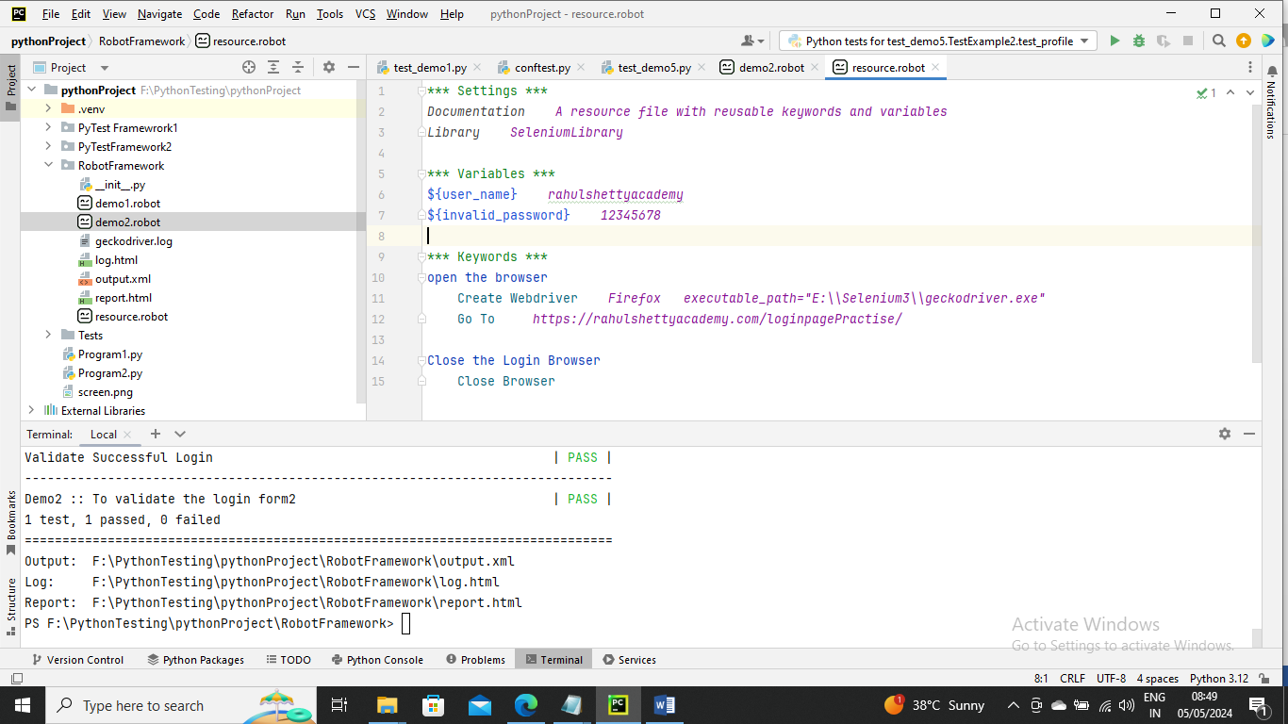

Below is main program

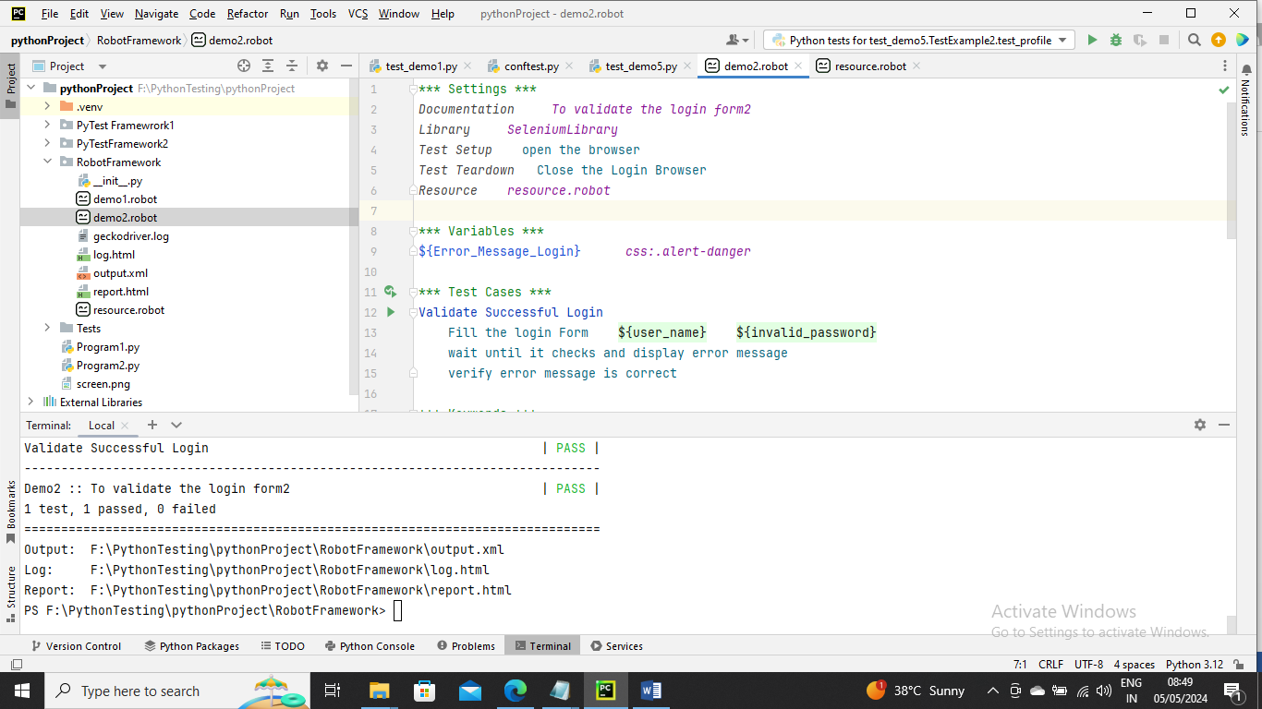

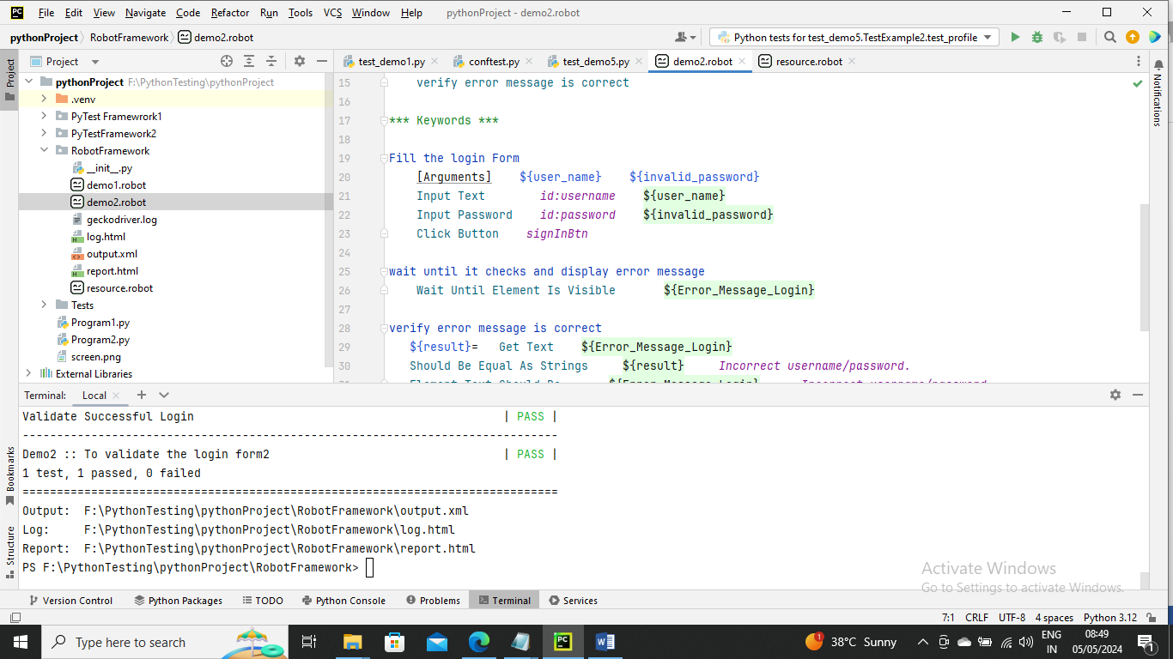

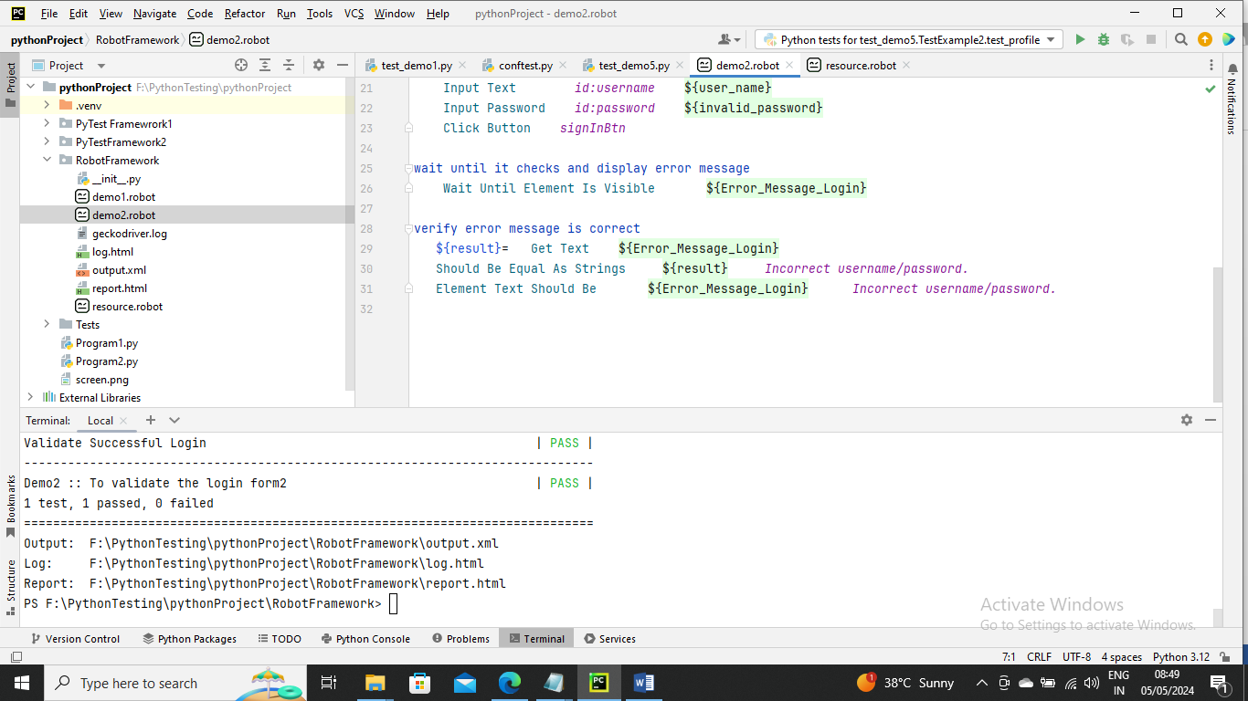

-----------------

Below is an example I have two different test cases “Validate non-Successful Login” and “Validate Cards display in the Shopping Page” and these both have Login and waiting for element location as common but with different values.

So using Robot Framework Automation you can optimize by having a single keyword. The argument will pass values since both test cases has different values one time invalid password and other valid password (for keyword Fill the login Form) and same locator data is different for two test cases (for keyword wait until Element is located in the page)

Below resource file is added with one more variable valid password

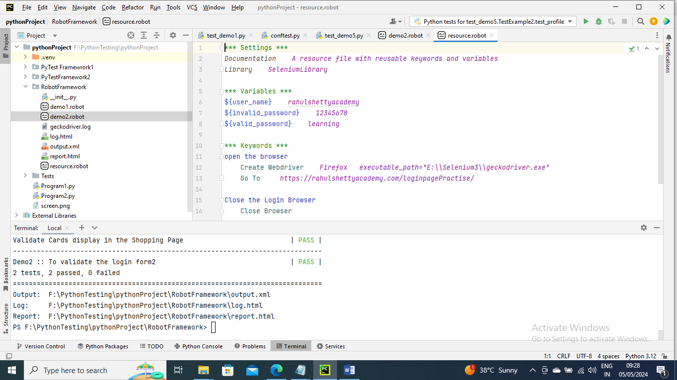

Below is main program

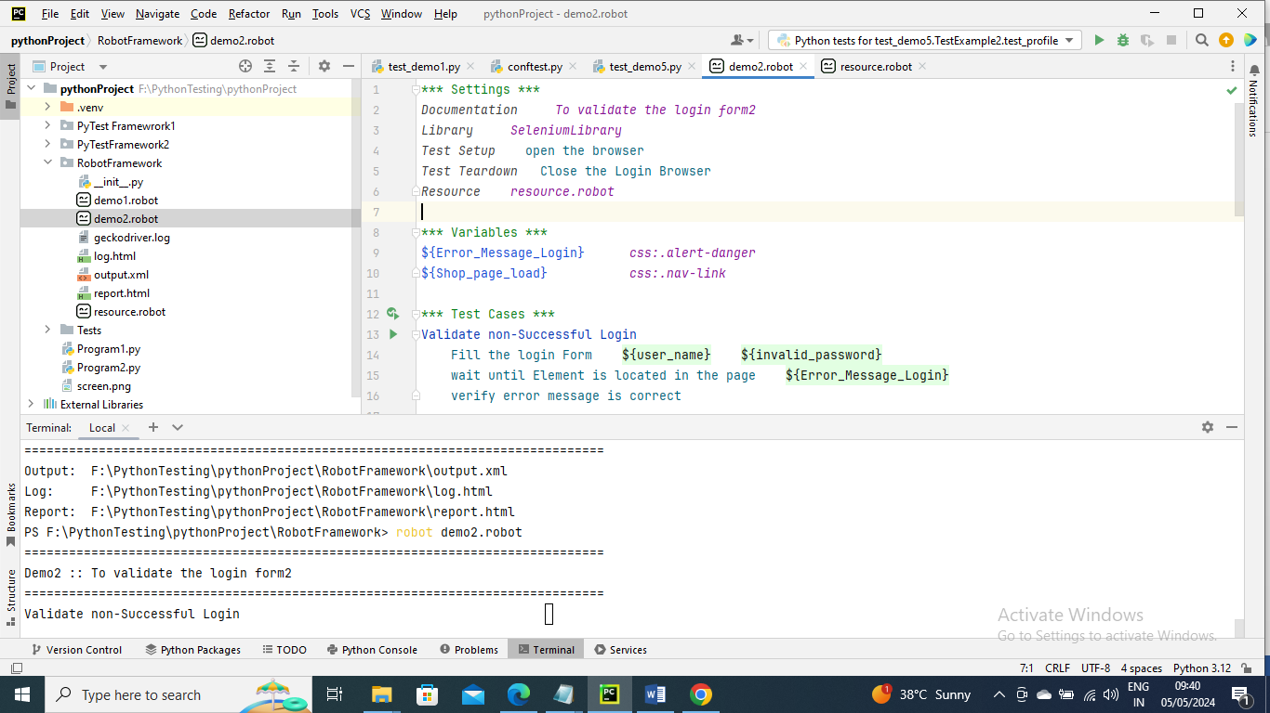

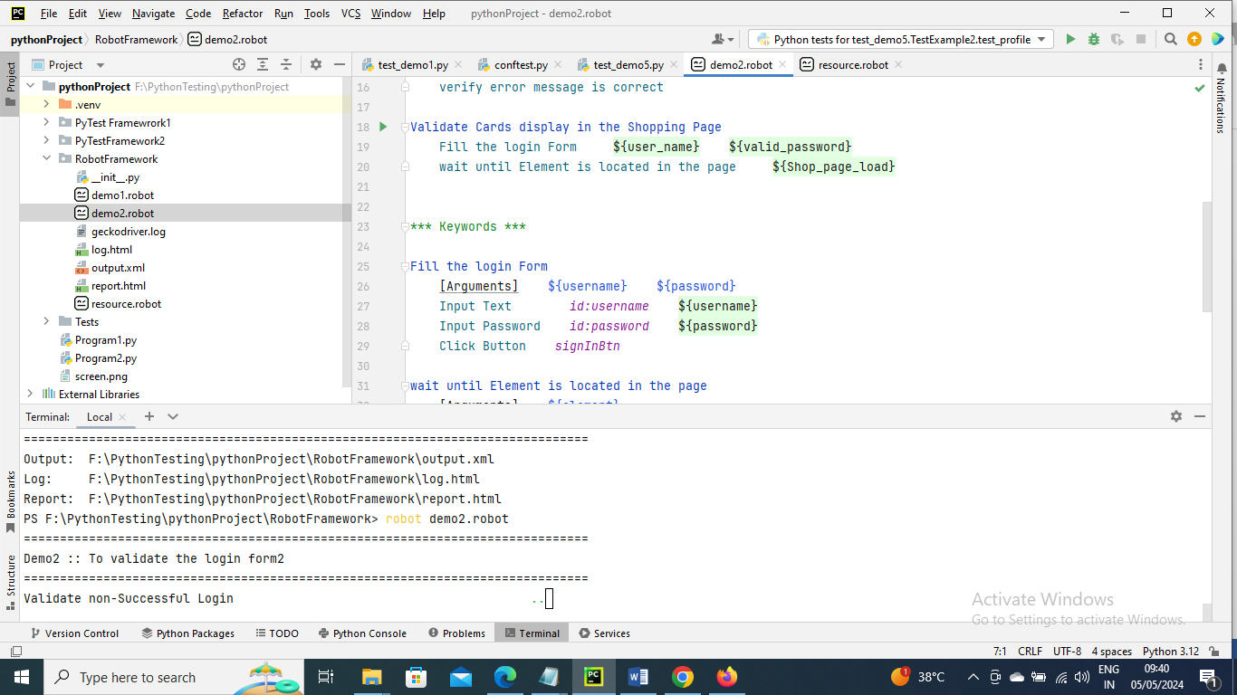

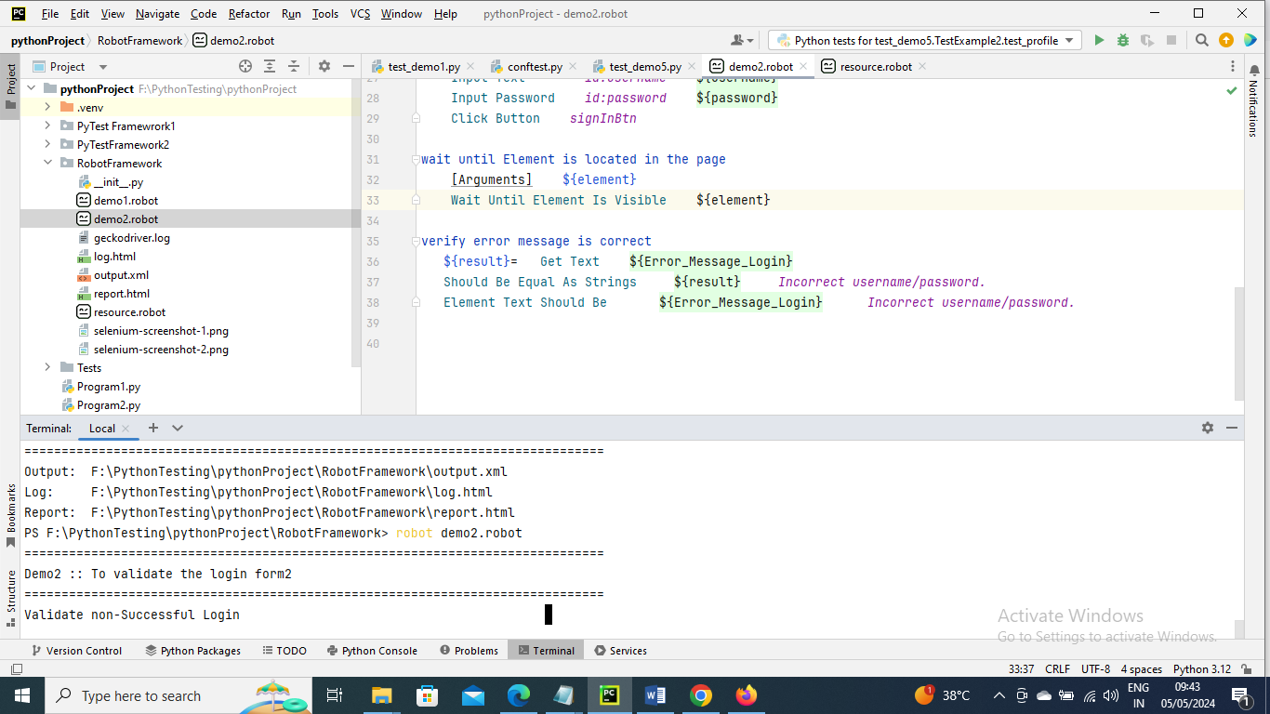

Now run the command for output both will pass

Output of successful login

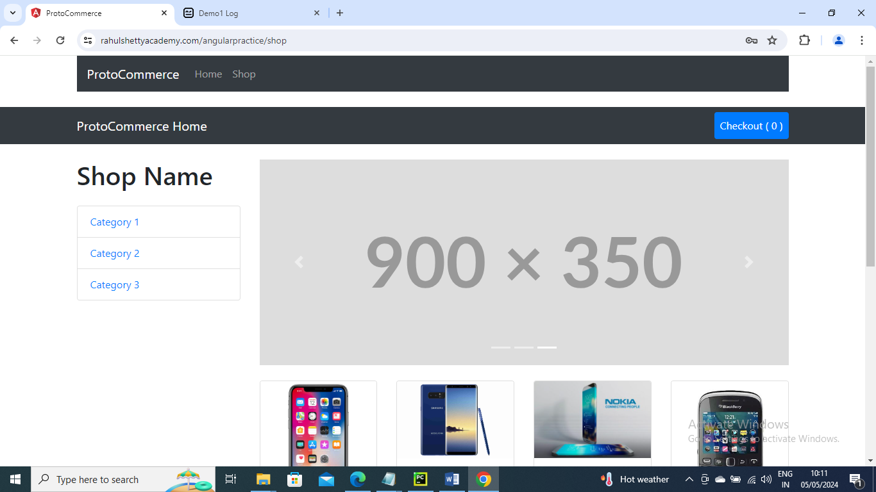

--------------------

How to retrieve the list of webelement

Below is an example on how to get the list of items in Web element and compare with our list. Here when we use log the list we will get printed in log file

For simplicity I have removed un-successful login as it is not required and so that code looks small and precise

Note – You need to give Library Collection for creating List and if using strings then String

Below resource file is not changed

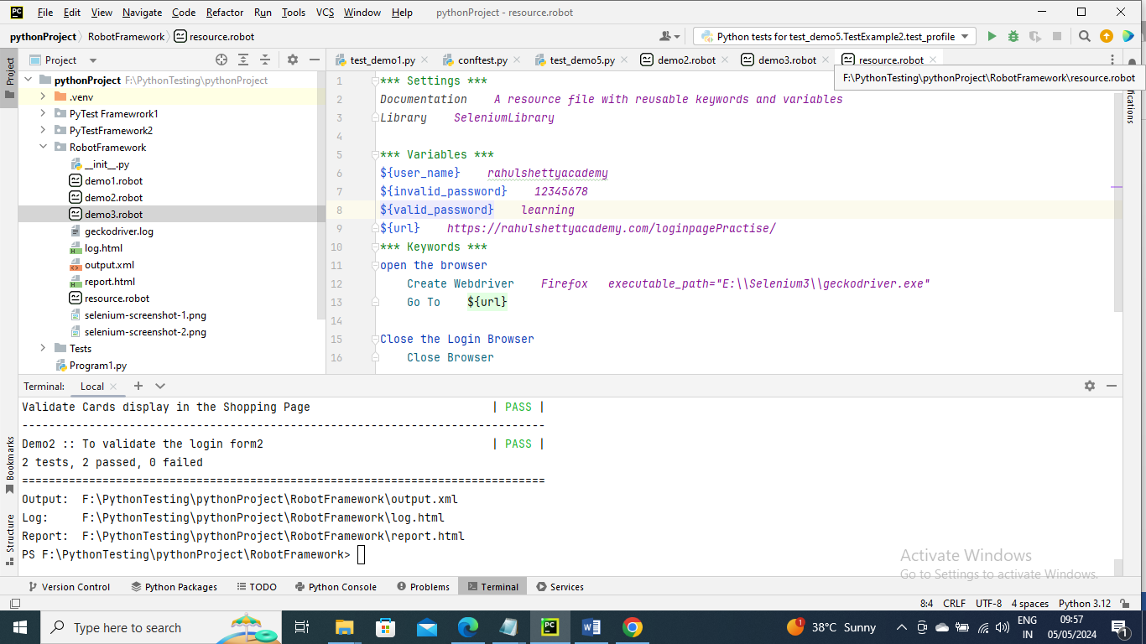

The below main program “verify card Titles in Shop page” we are comparing with our list with data in element by taking them in another list and logging all the element in log file

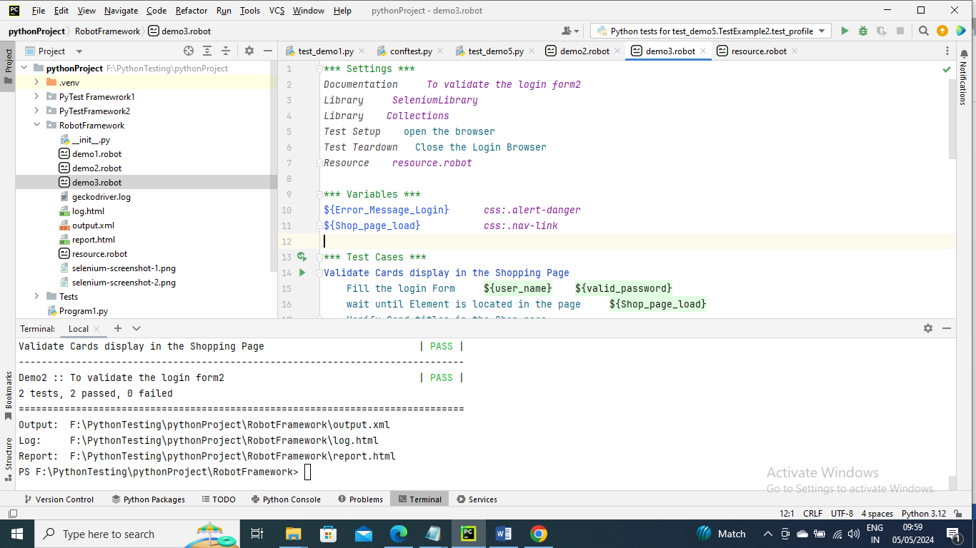

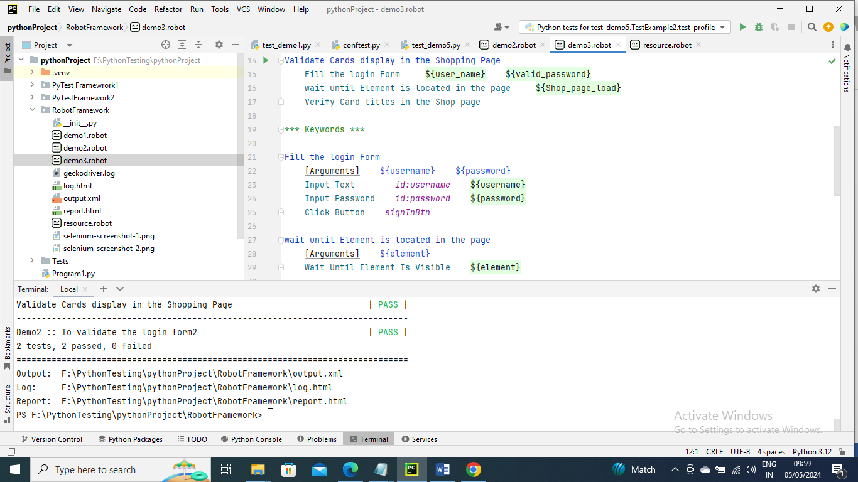

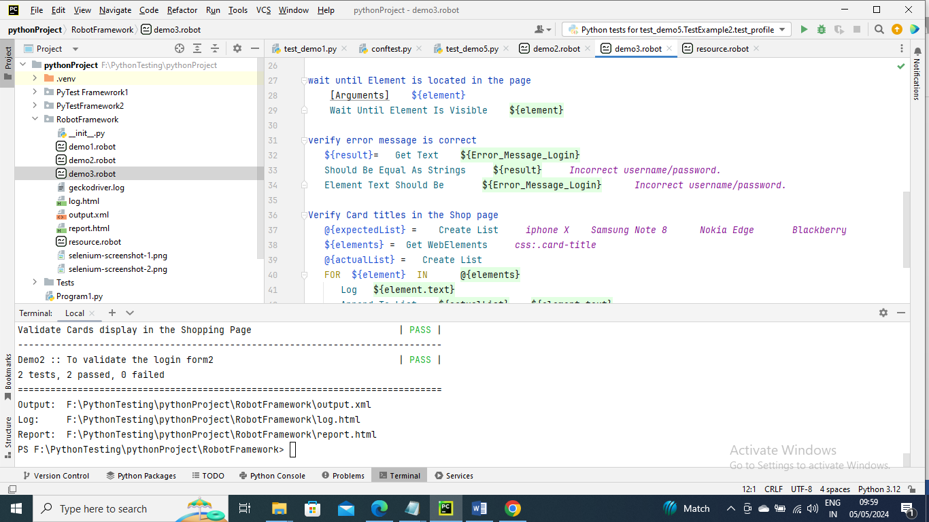

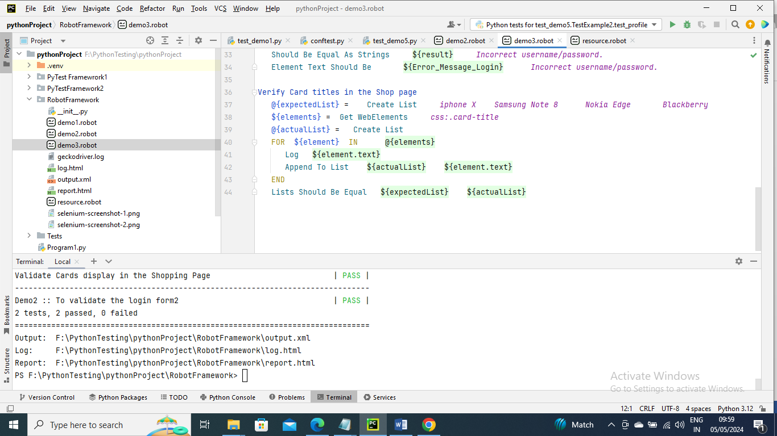

Now run the program using command

Below is the output in log file where elements are printed

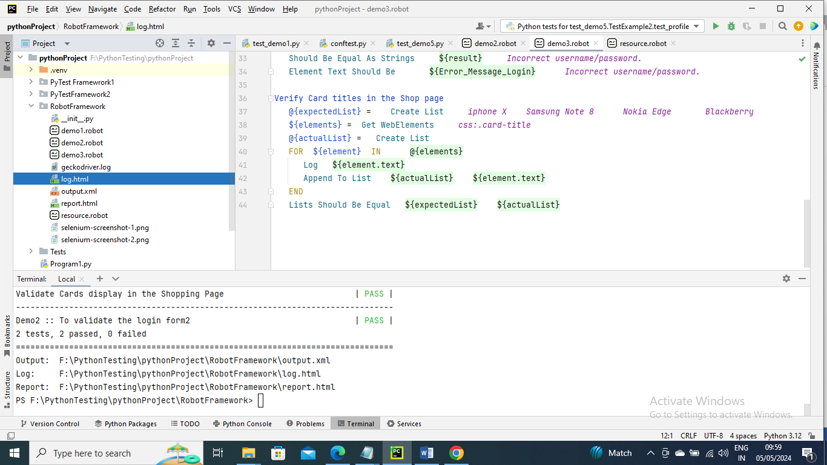

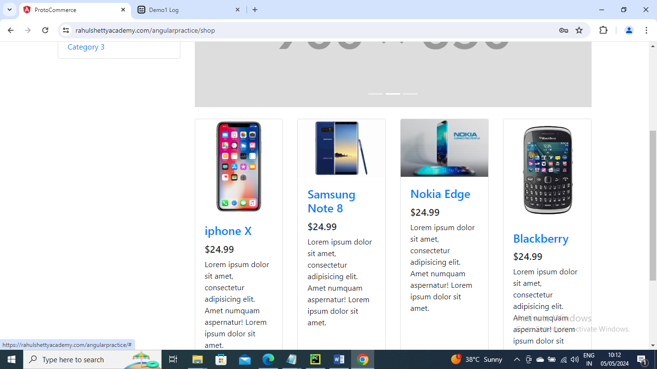

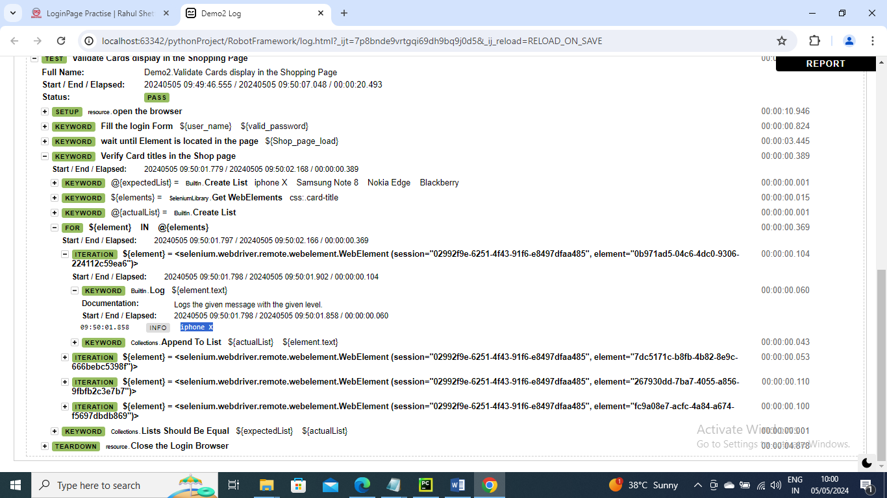

And you can expand to see other values

--------------------------

Below is an example where we are we are selecting the card Nokia Edge

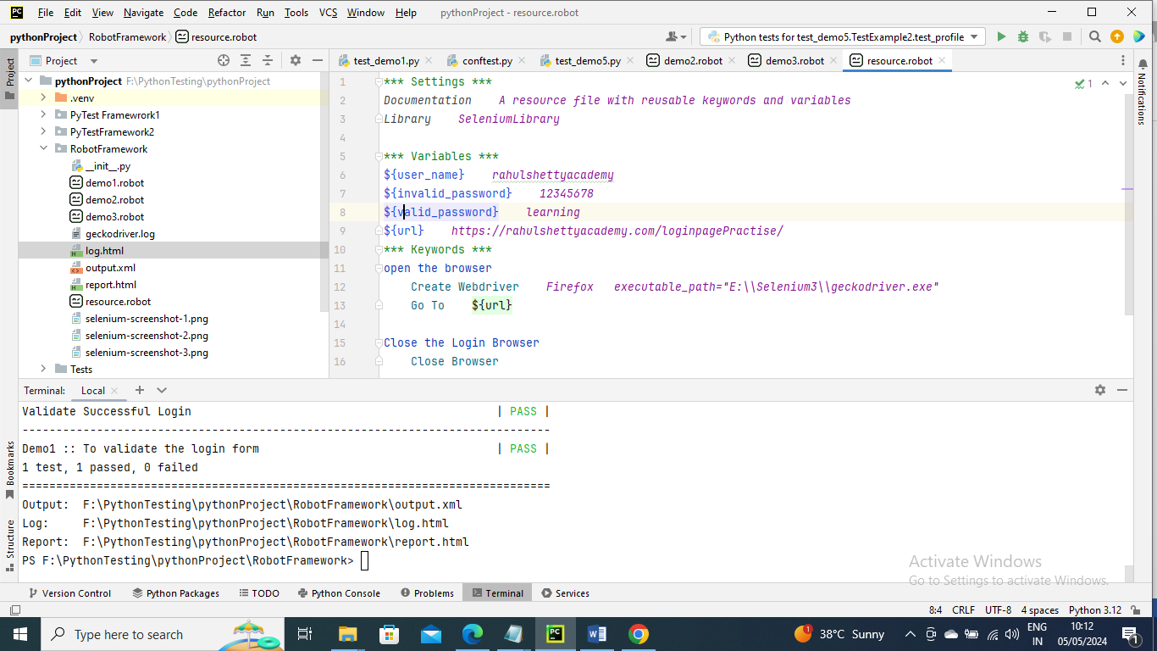

Below is main program

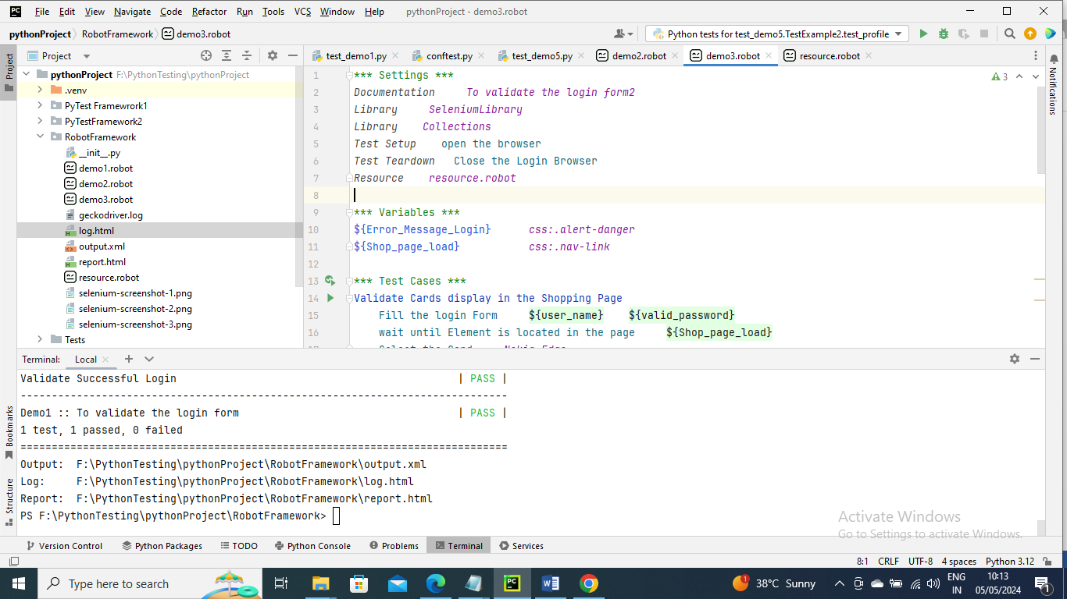

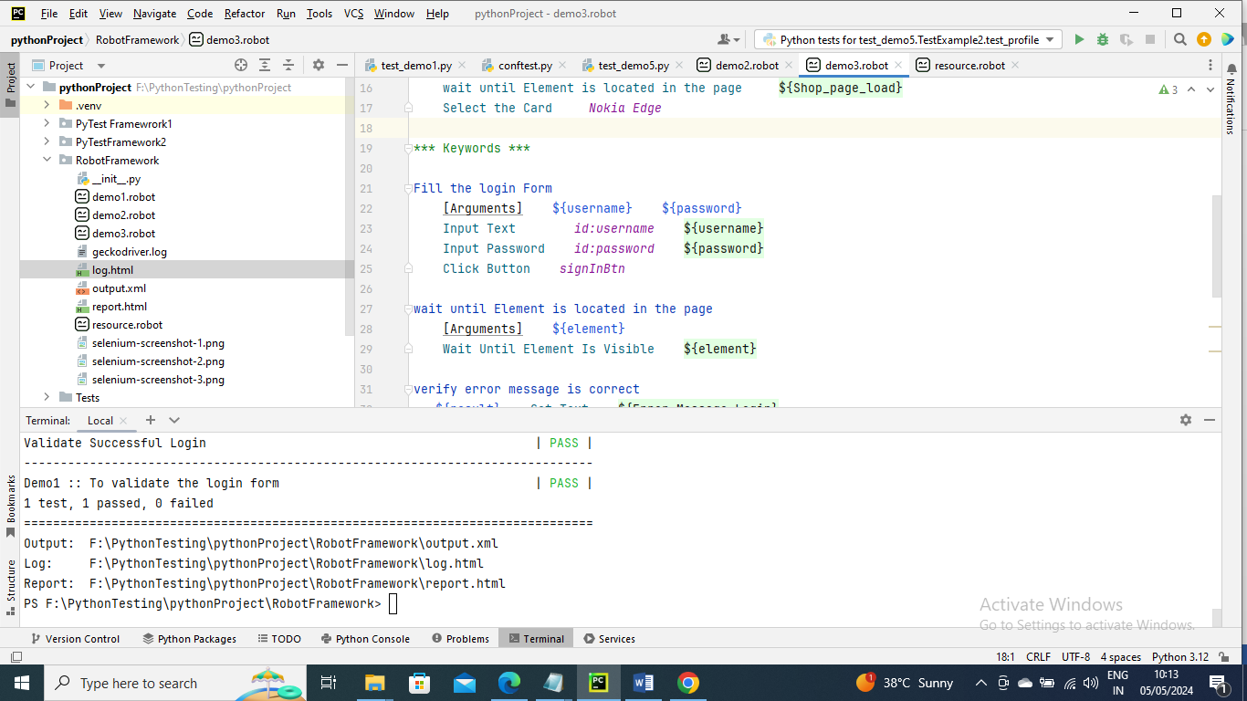

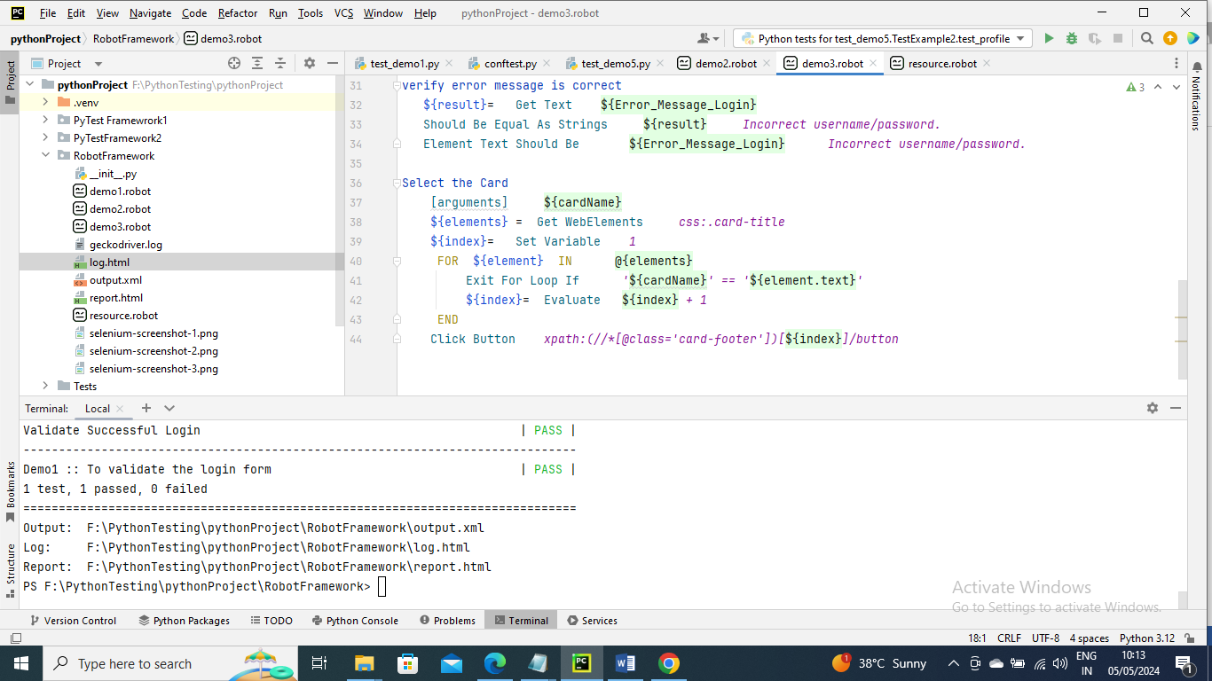

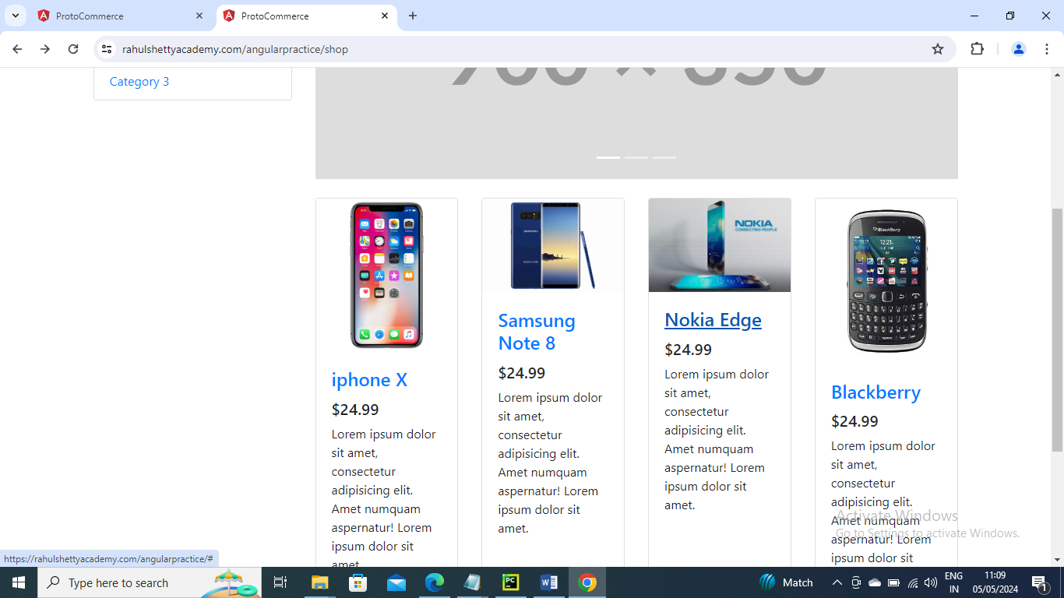

-----------------------------

Below is an example where we see how to select radio button, drop down, check box and other

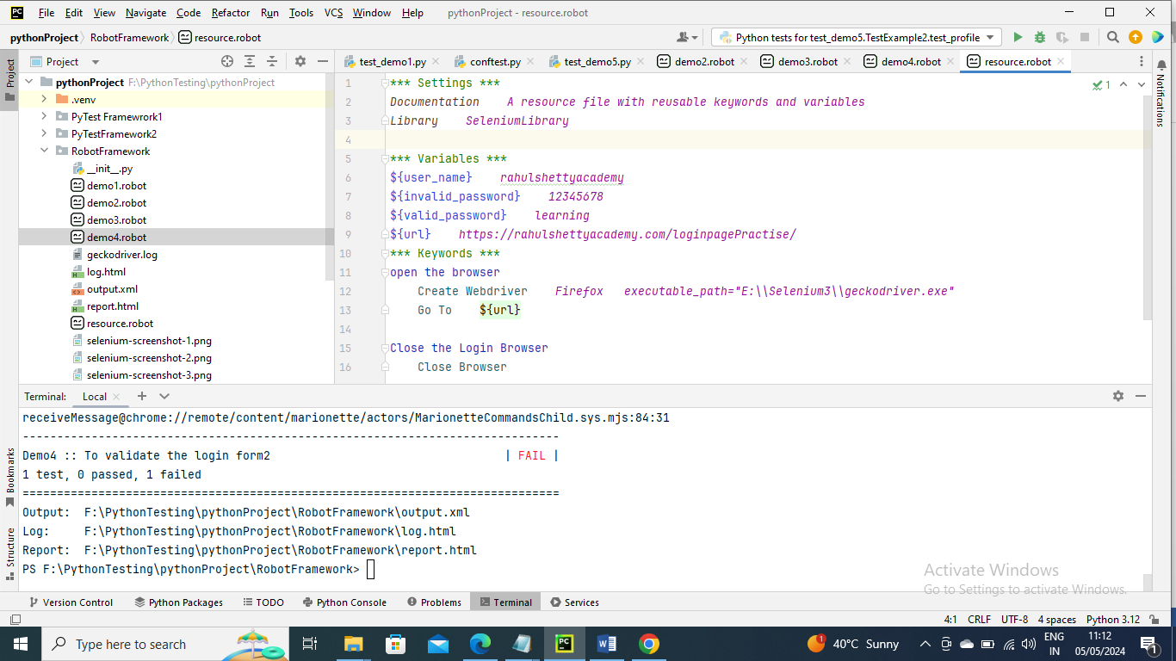

Below is main program

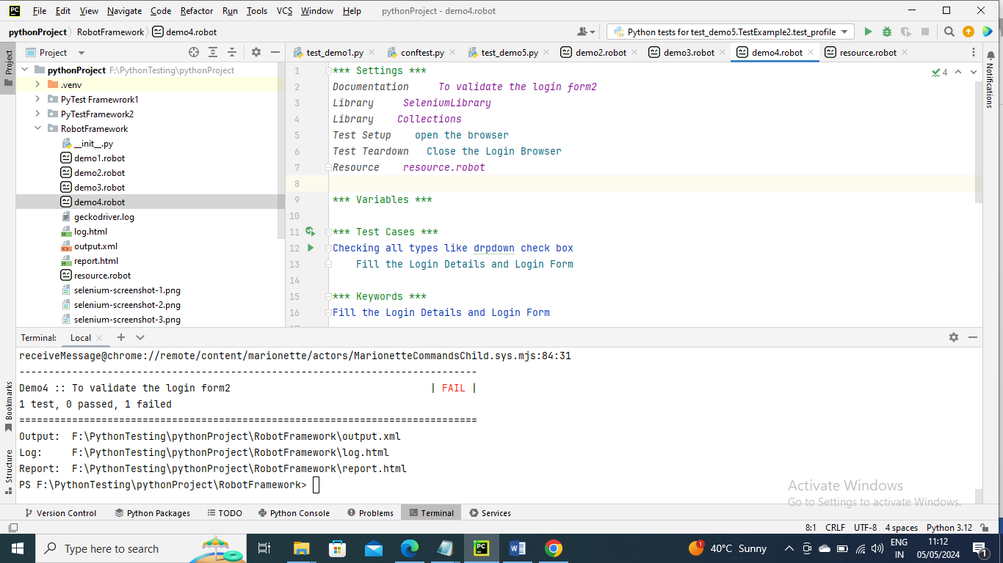

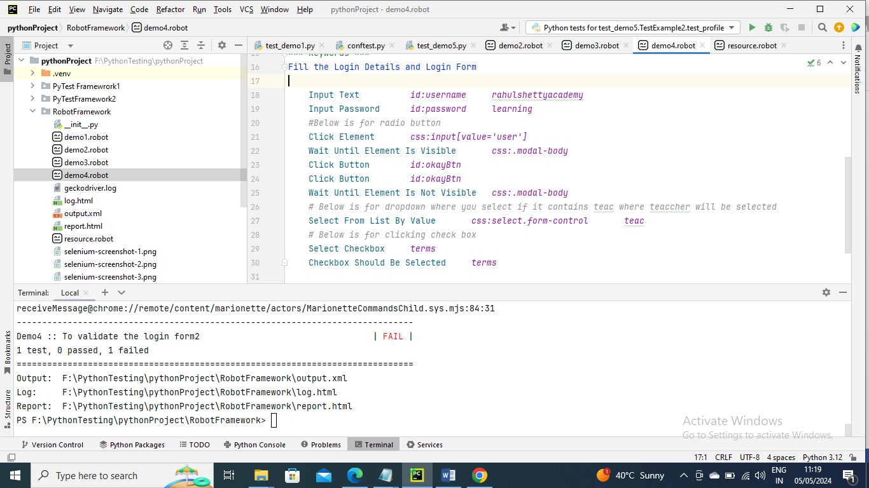

Run the command robot demo4.robot for output

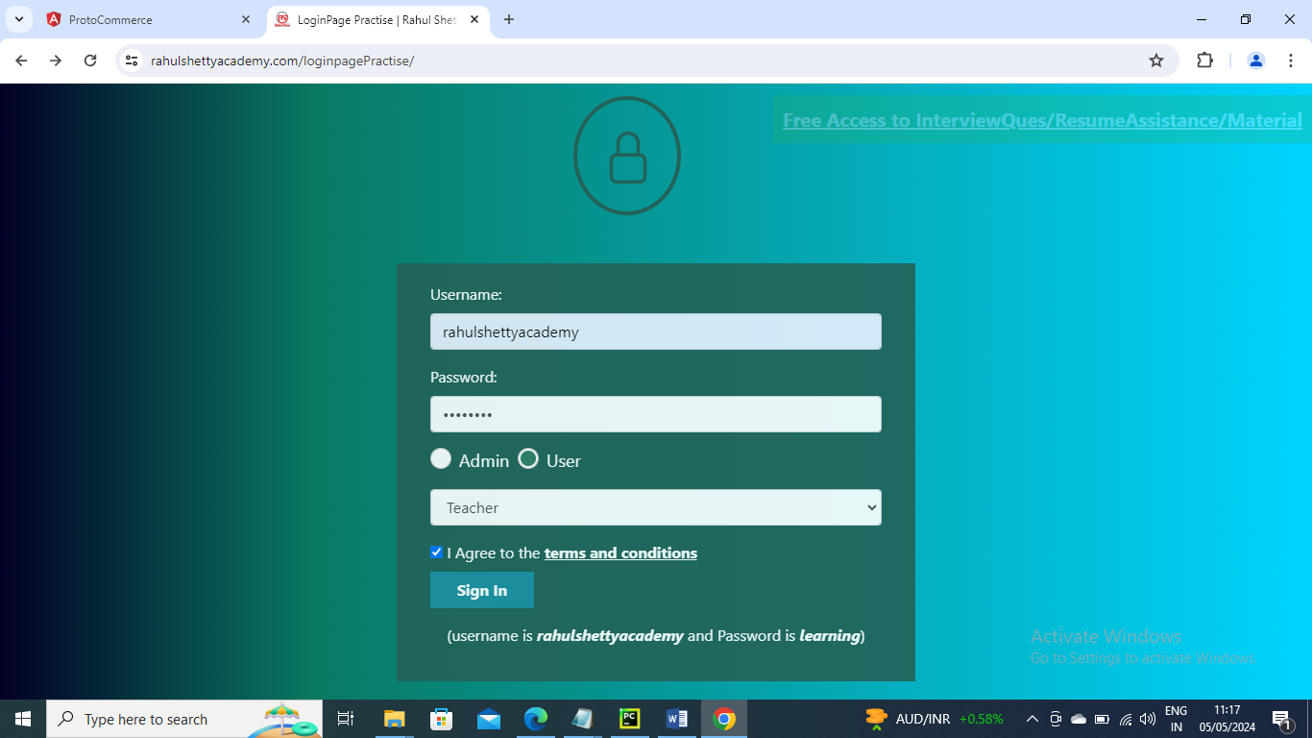

---------------------

In the below example is an example of how to switch from child window to parent window and vice versa

Scenario :

Click on the “Free Access to….” link it will open in new Tab

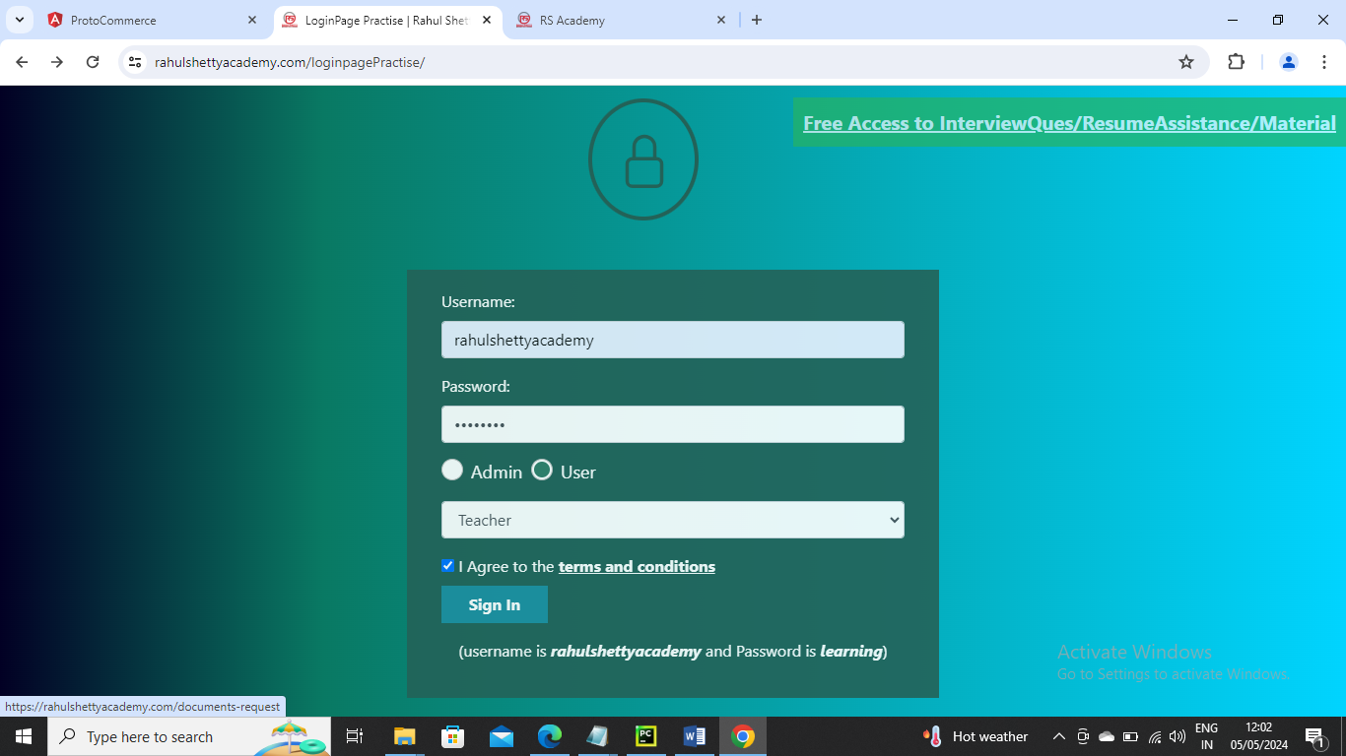

Now move the control to that window get the data from a line [mentor@rahulshetty.com](mailto:mentor@rahulshetty.com) and move control to parent window and paste in username again

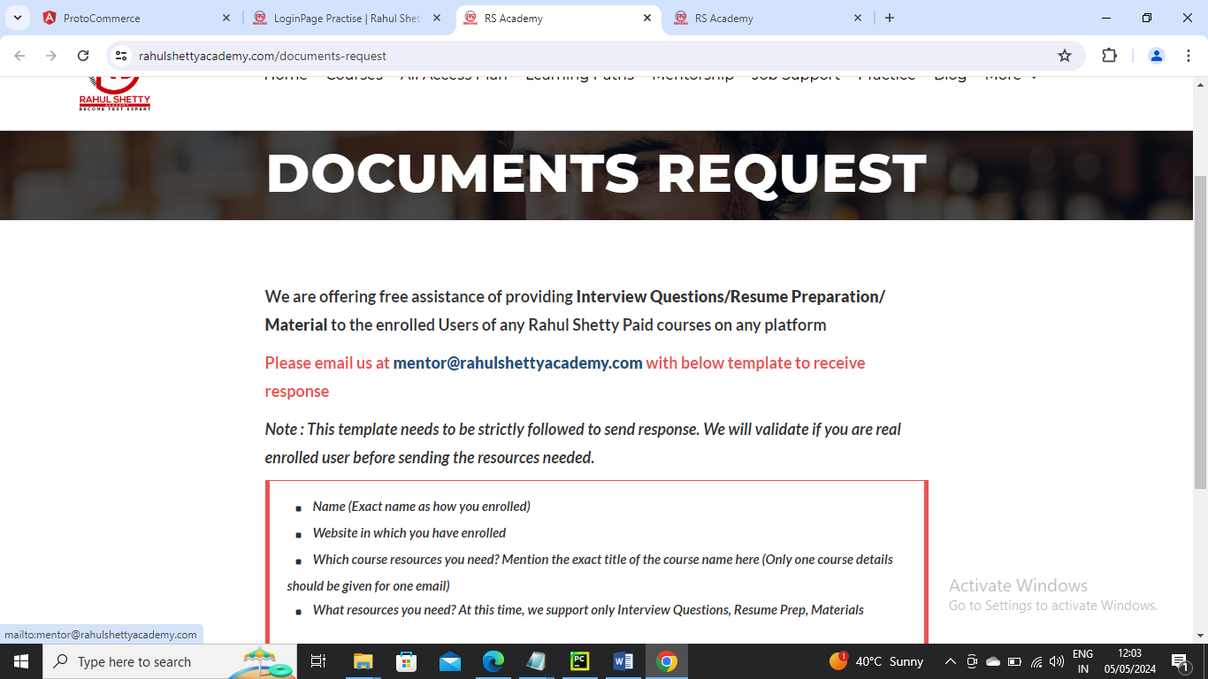

In below we have moved control to child window took the data and splitted it get desired data and switch control, to parent or MAIN window and pasted the desired data in text box

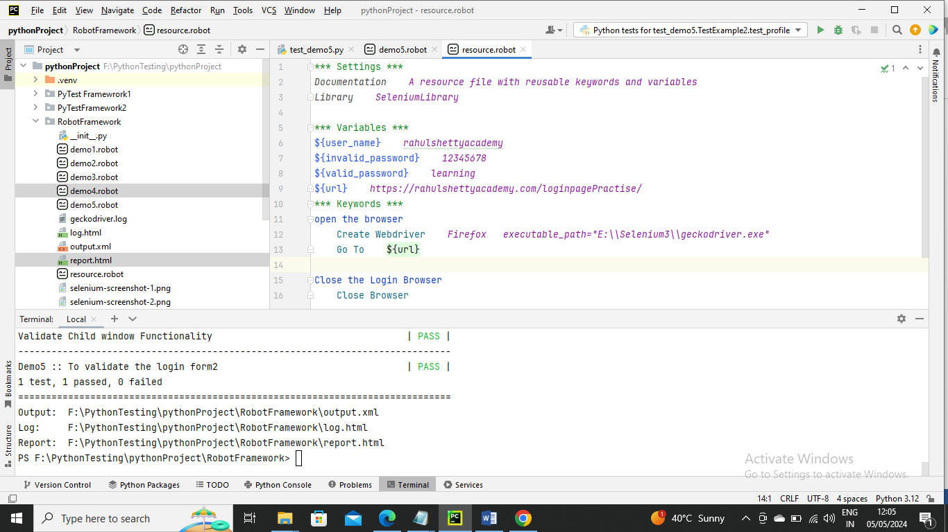

Below is main program

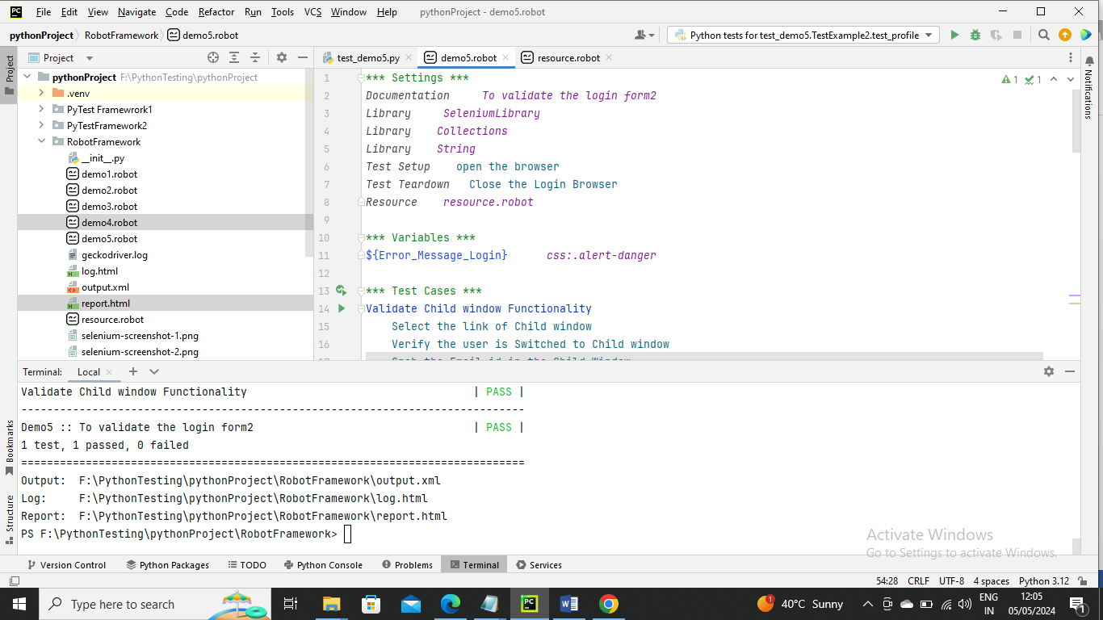

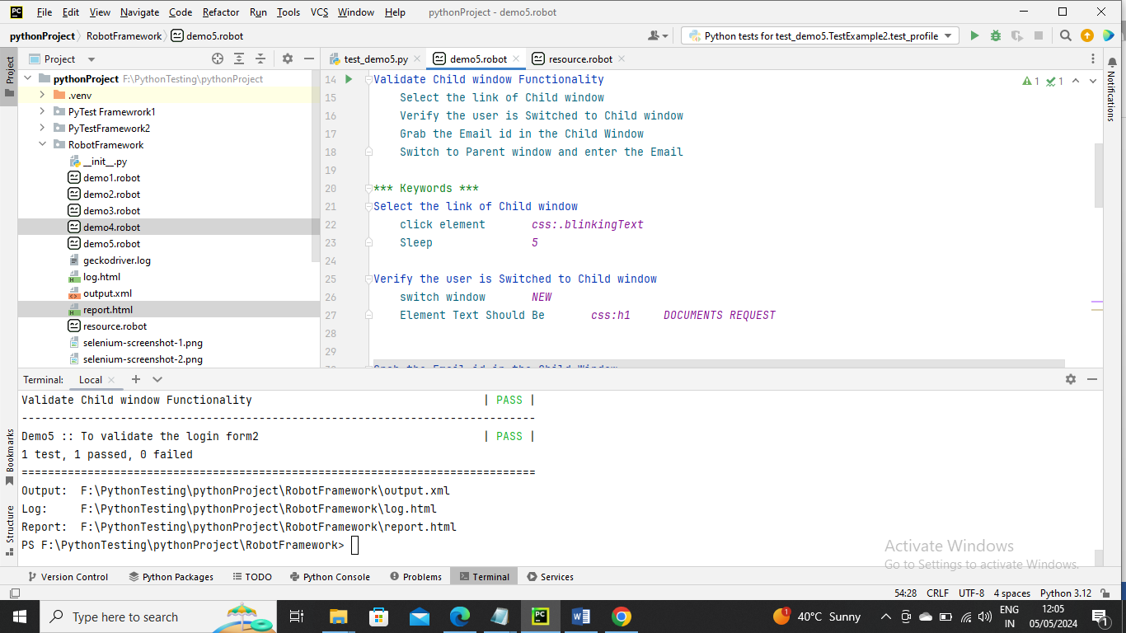

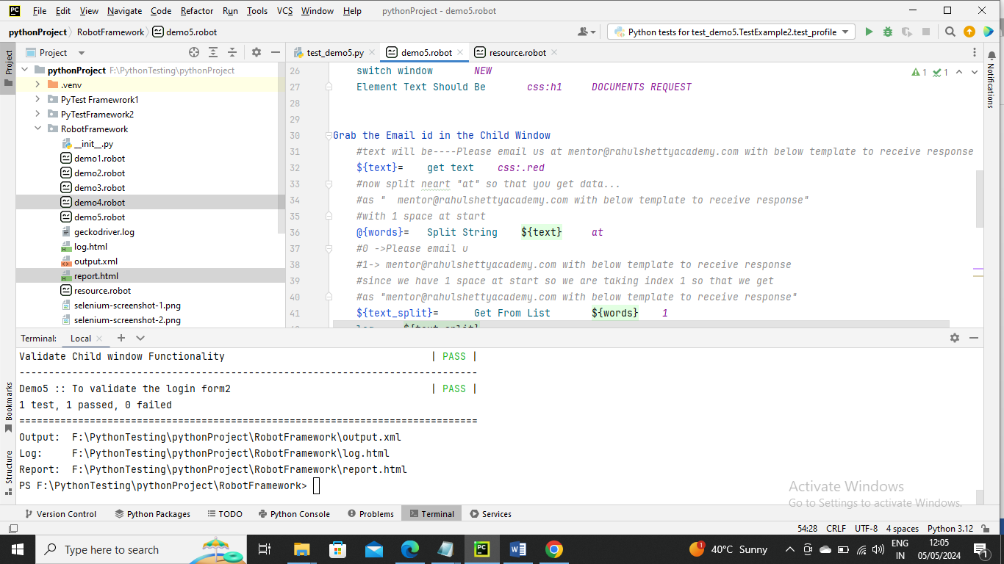

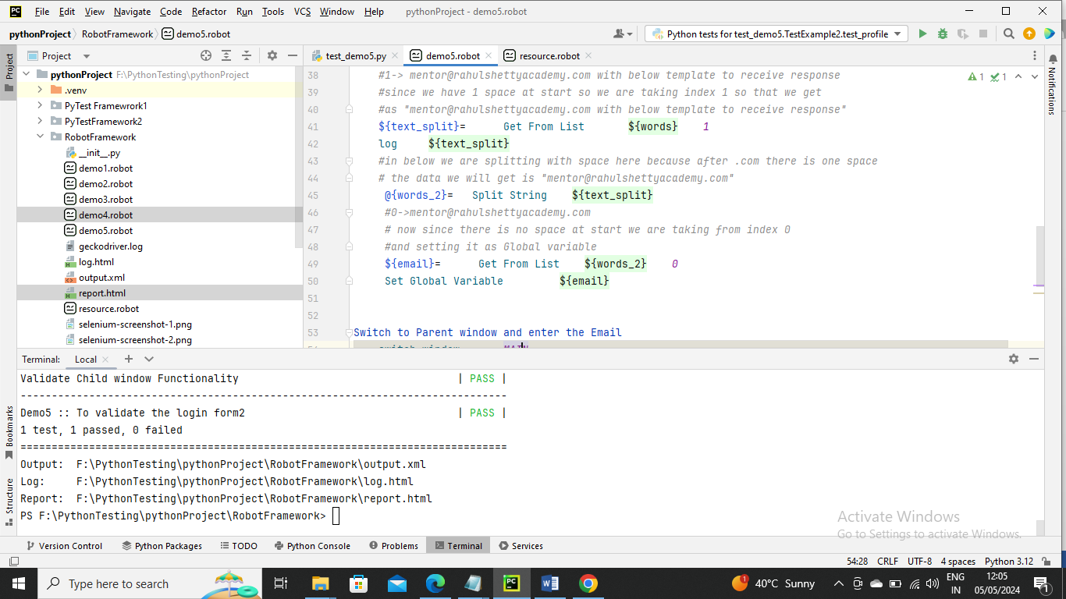

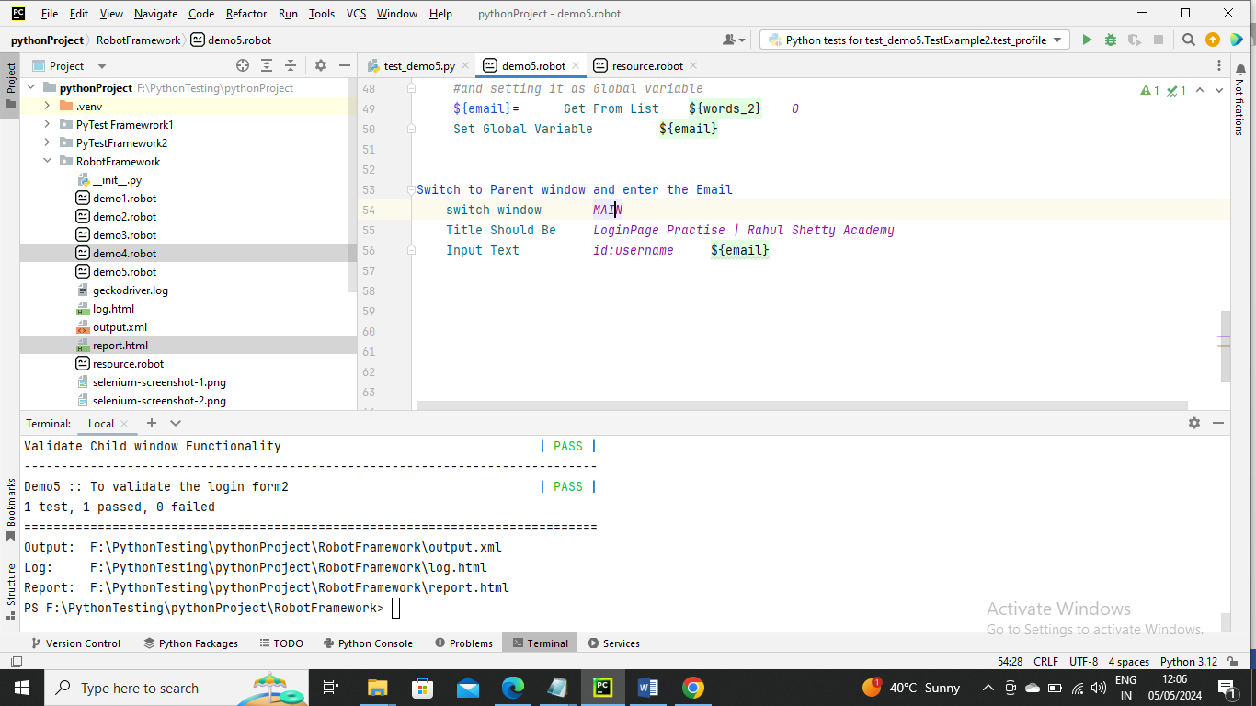

Now run the program you get data from child window and pasted in MAIN window

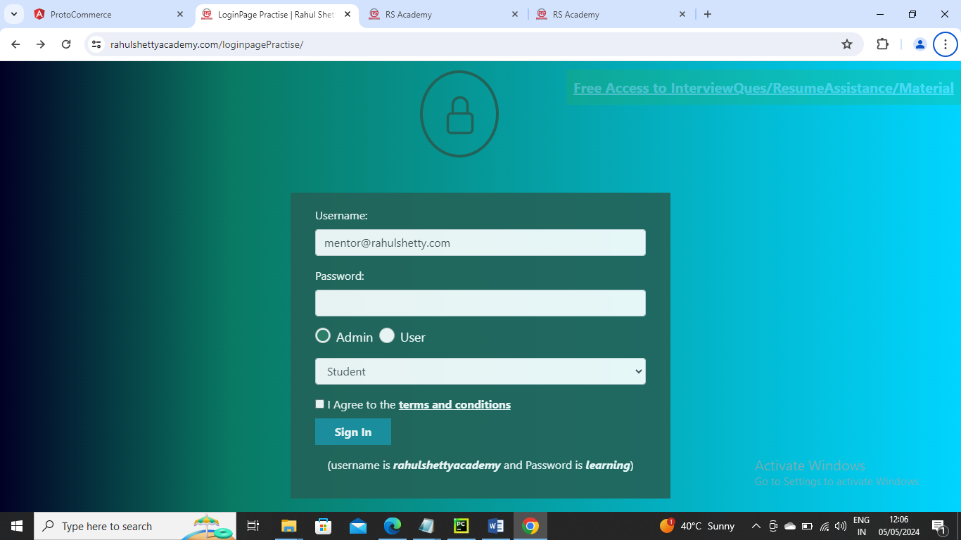

--------------------

Until now we saw passing parameter only once

Below is an example where you password multiple usernames and multiple passwords for a login screen

Below is resource program

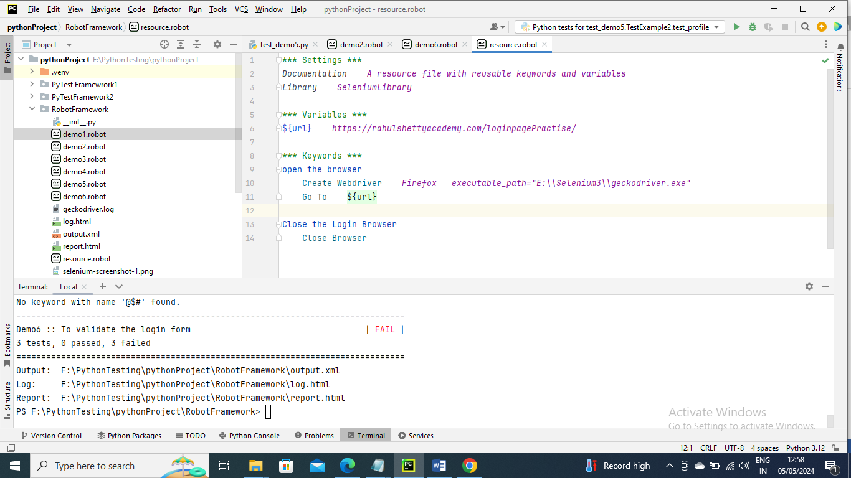

Below is the main program

Here we are passing the multiple parameters from Test case so here we cannot have Test case and its key words

Here you need to have Test case and keywords in Keyword section at first just the way you write in Test cases and letter functionality of each keyword

Also you need give Test Template and Test case name given in keyword section

For example Test Template Validate Unsuccessful Login

So that the program will understand which Test needs to be executed

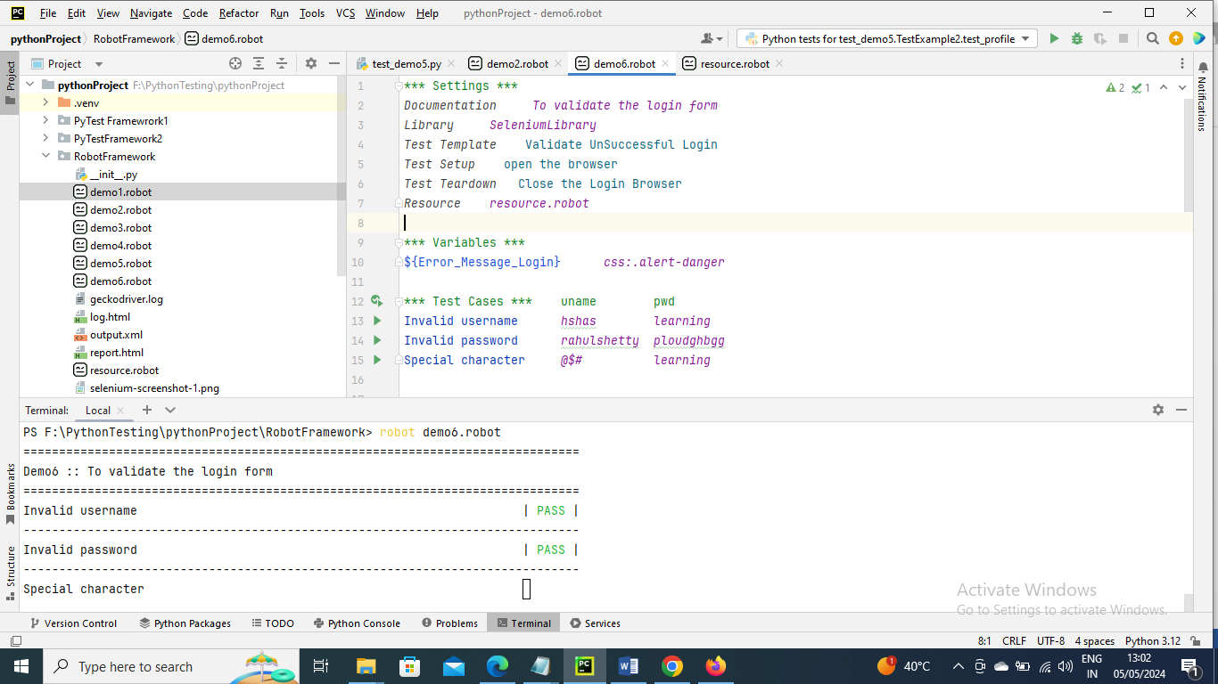

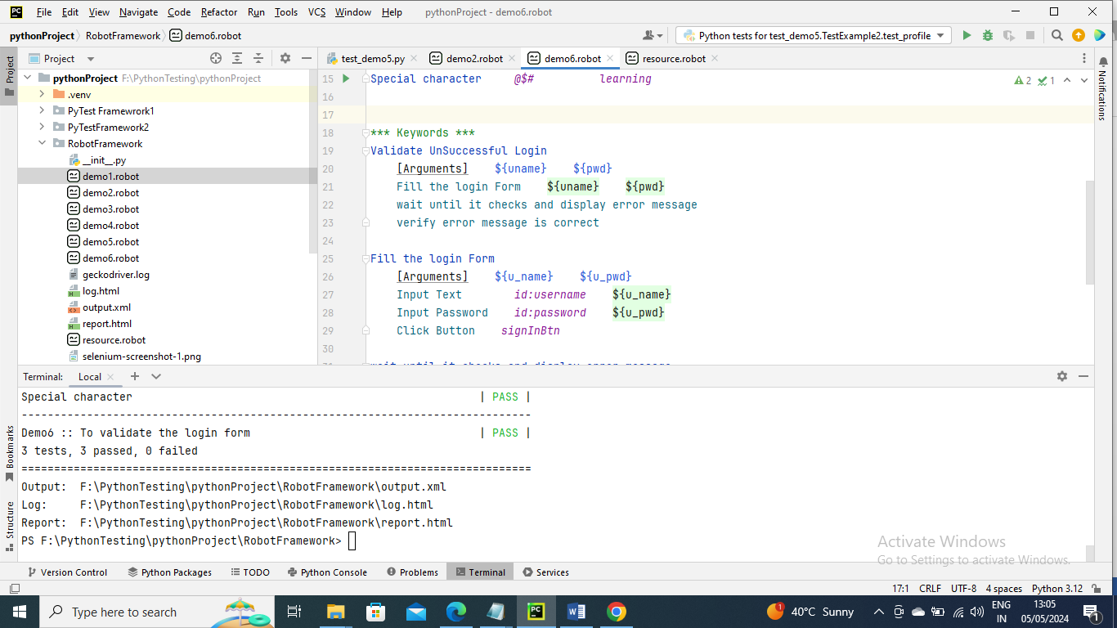

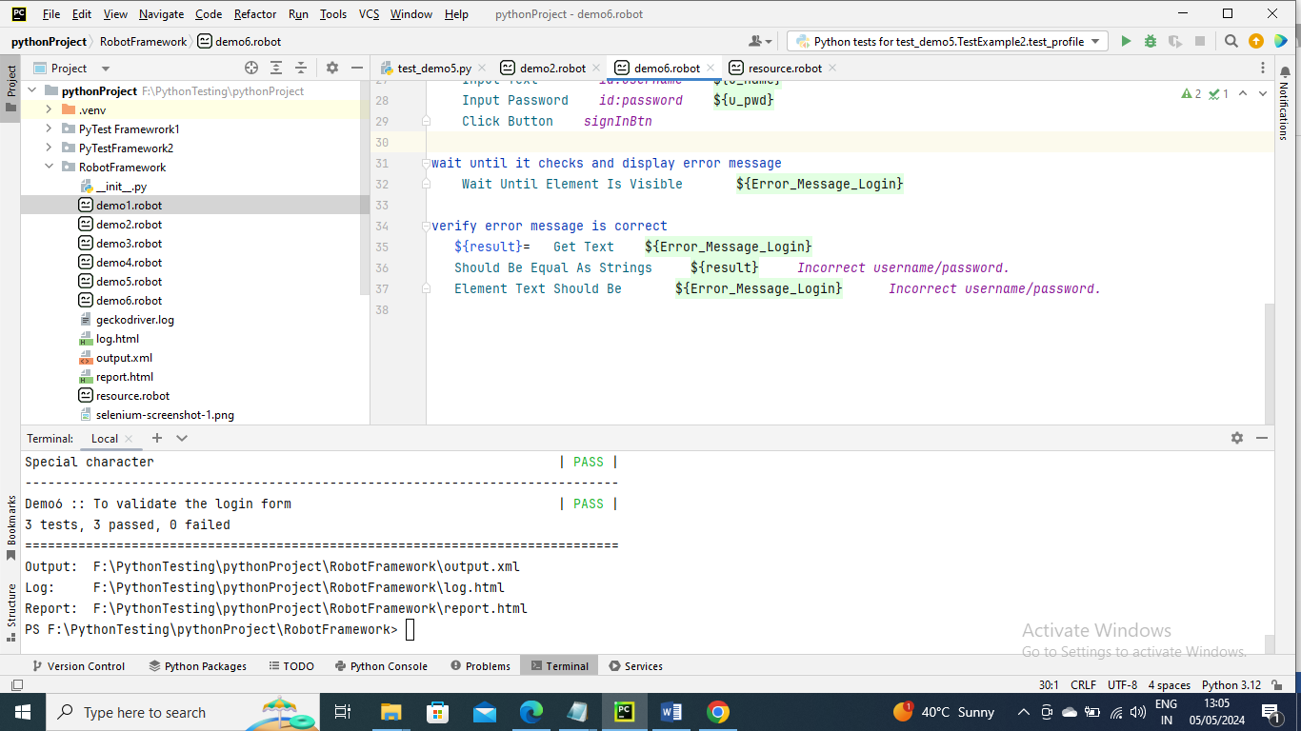

Run the command for output as usual….You will see the browser will try to login with three parameters first opens browser and tries and closes the browser and open browser again and tries second and closes and next same for third

---------------

Reports in Robotic Framework Automation

We don’t need to have any code for report, The robotic framework automation will generate report for us i.e. report.html

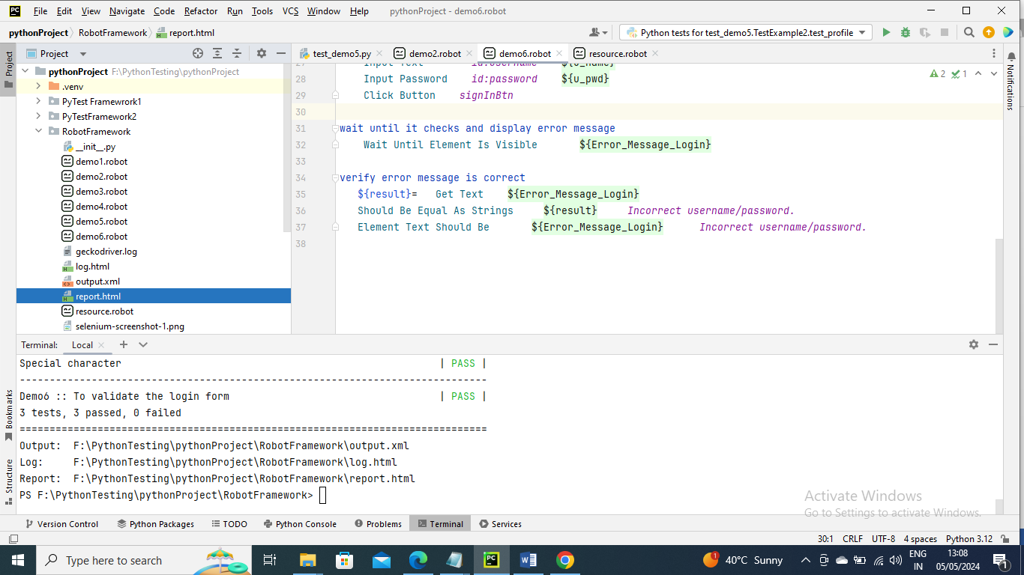

Below is the report for the above ran program for example

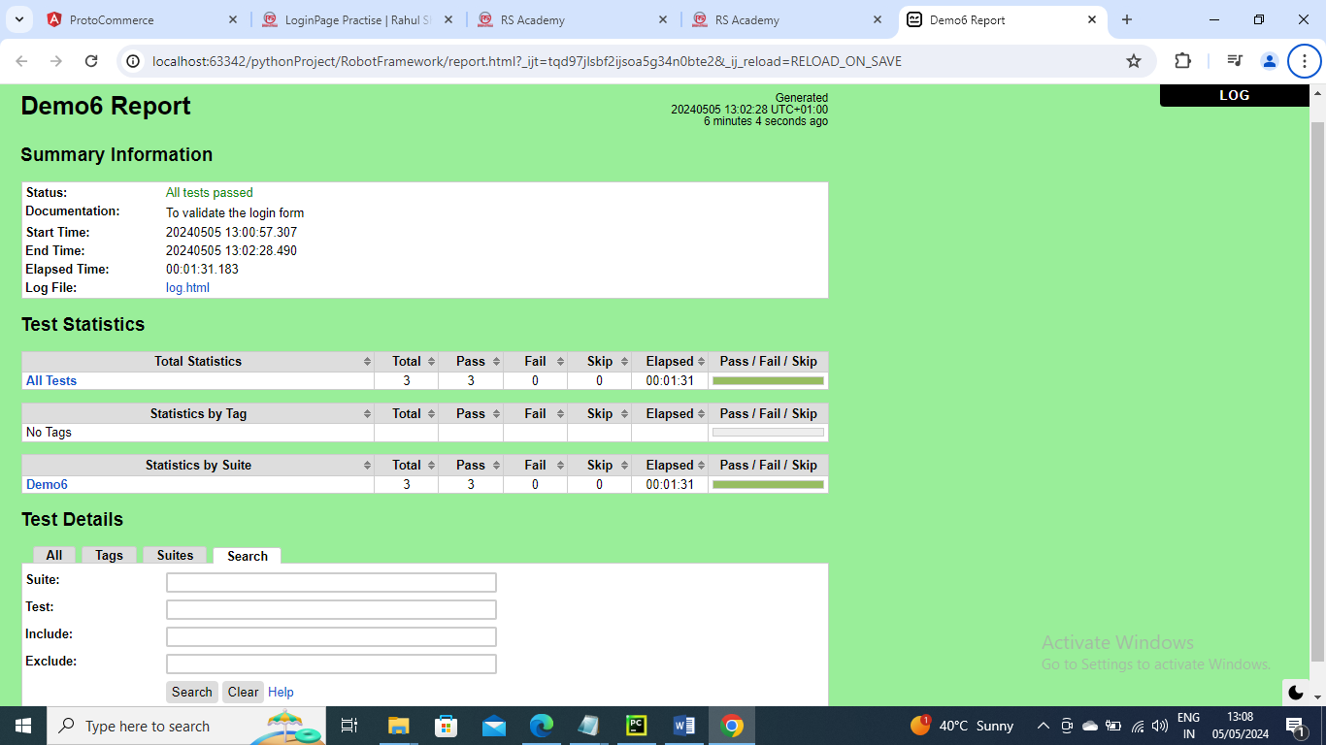

---------------

How to generate screenshot

In Robot Automation Framework you don’t need separate code to generate screenshot, Robot Automation Framework generates screenshot if something fails

Resource is same

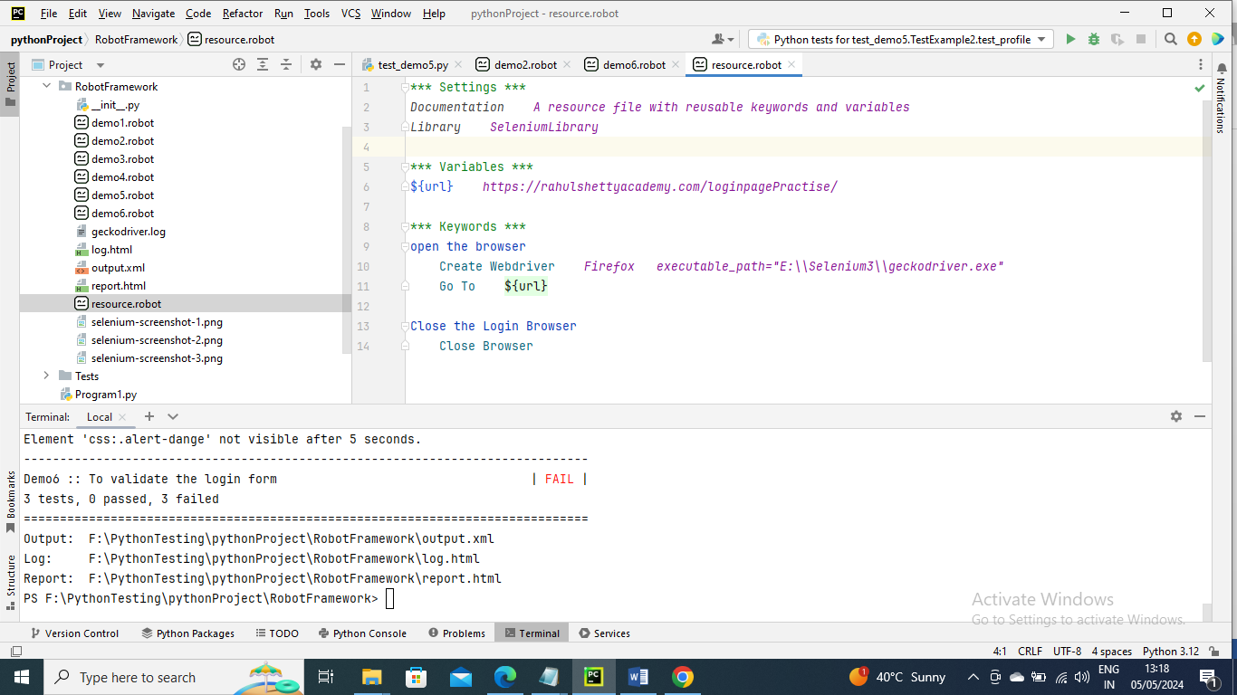

In below program I have wantedly changed error_message variable by removing “r”(i.e. danger to dange) at end so that it fails

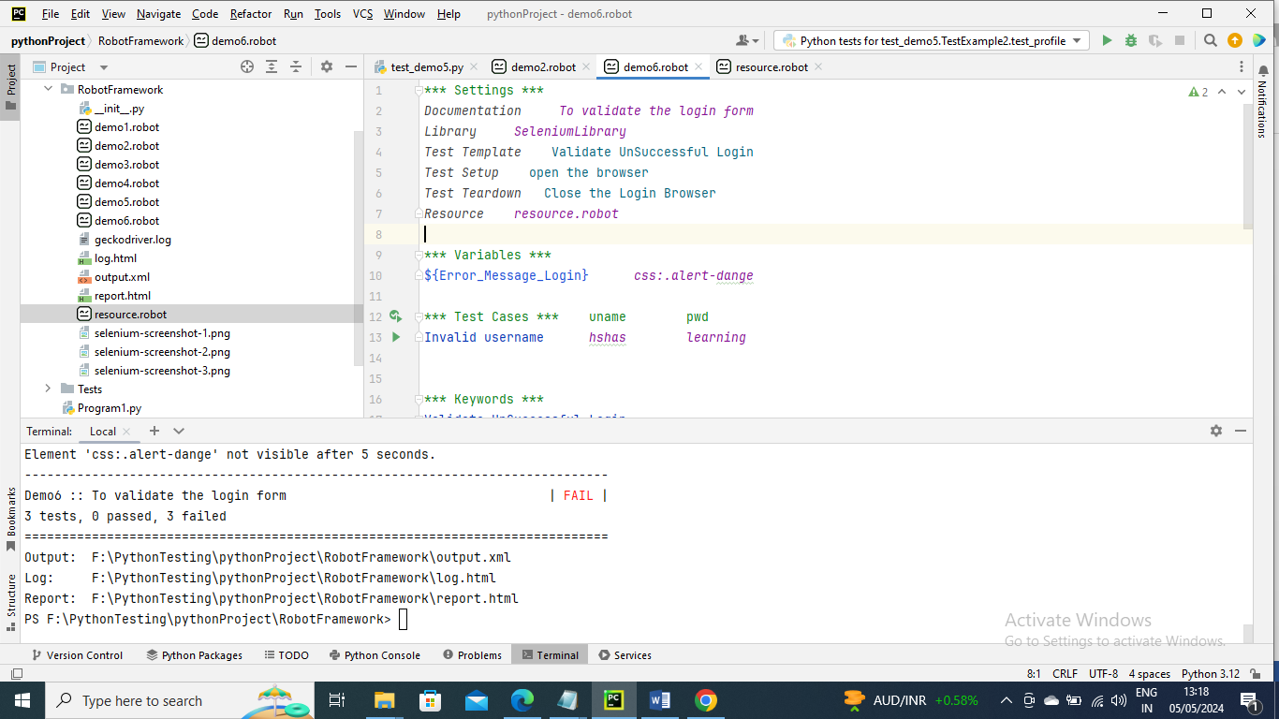

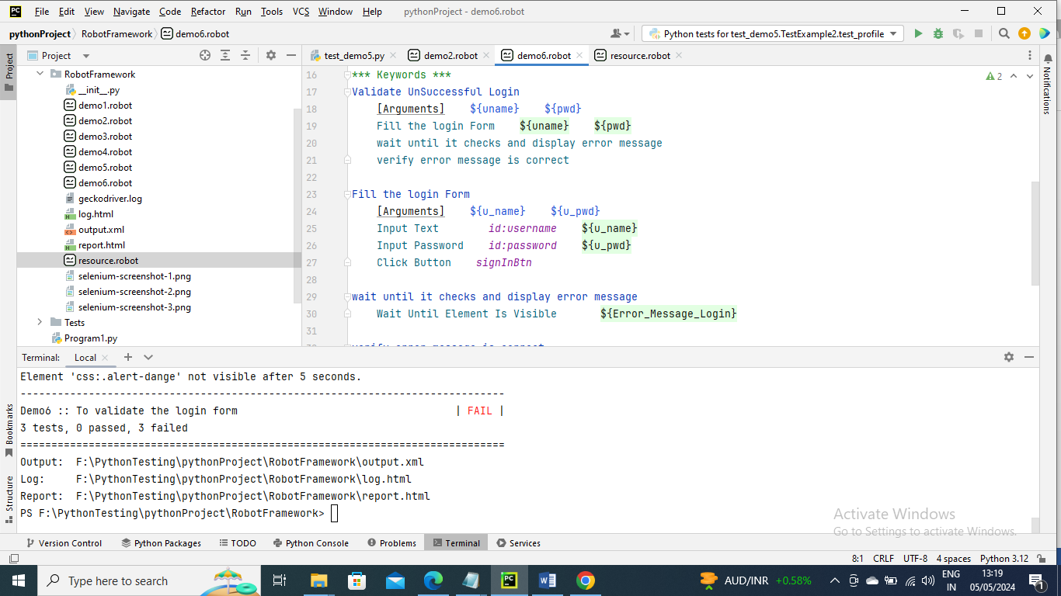

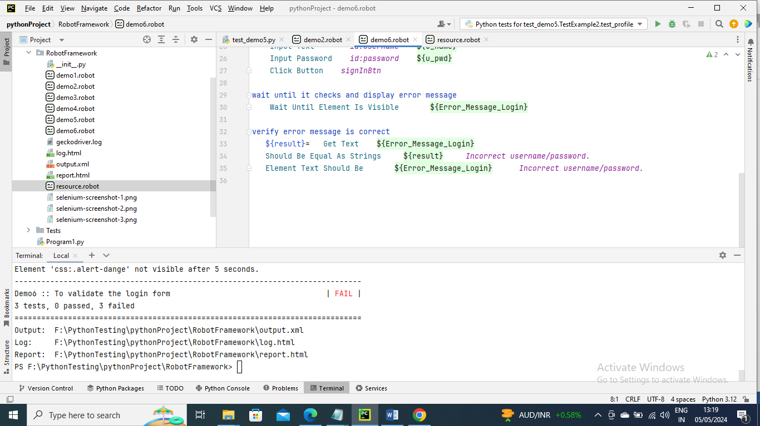

Now run the command for output

As you can see below since the test case failed a screenshot has been generated automatically

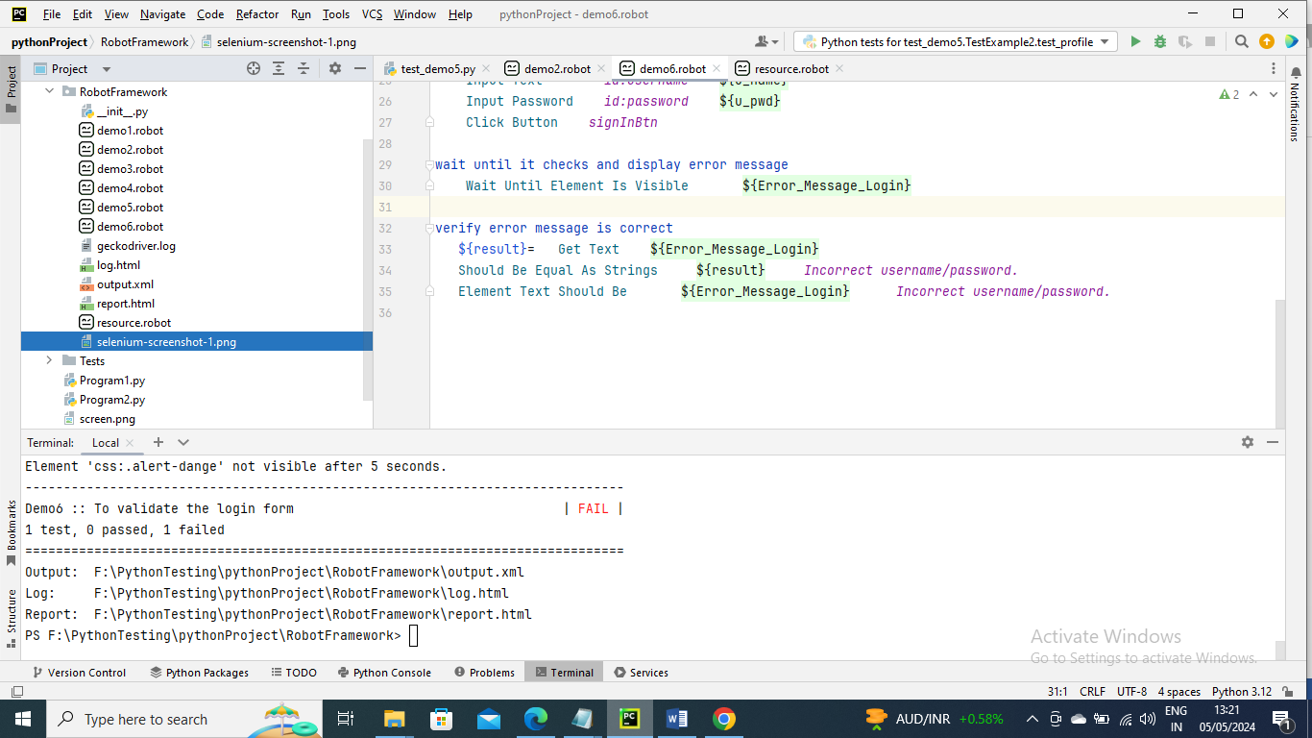

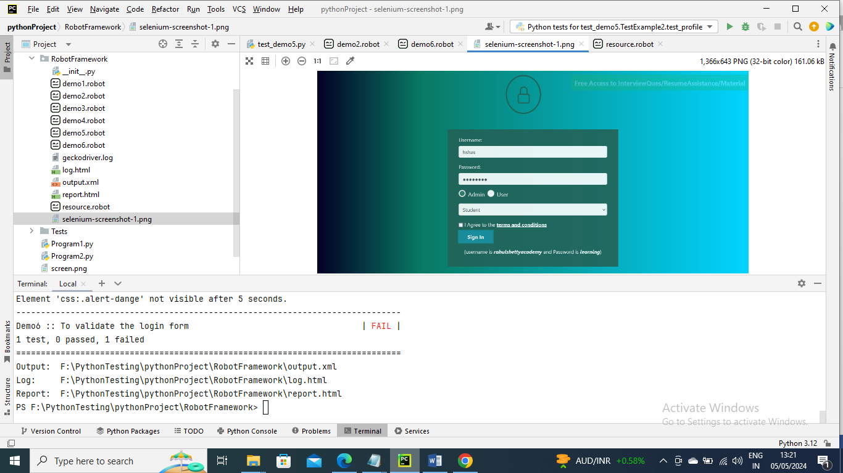

You can also see that in log file as well

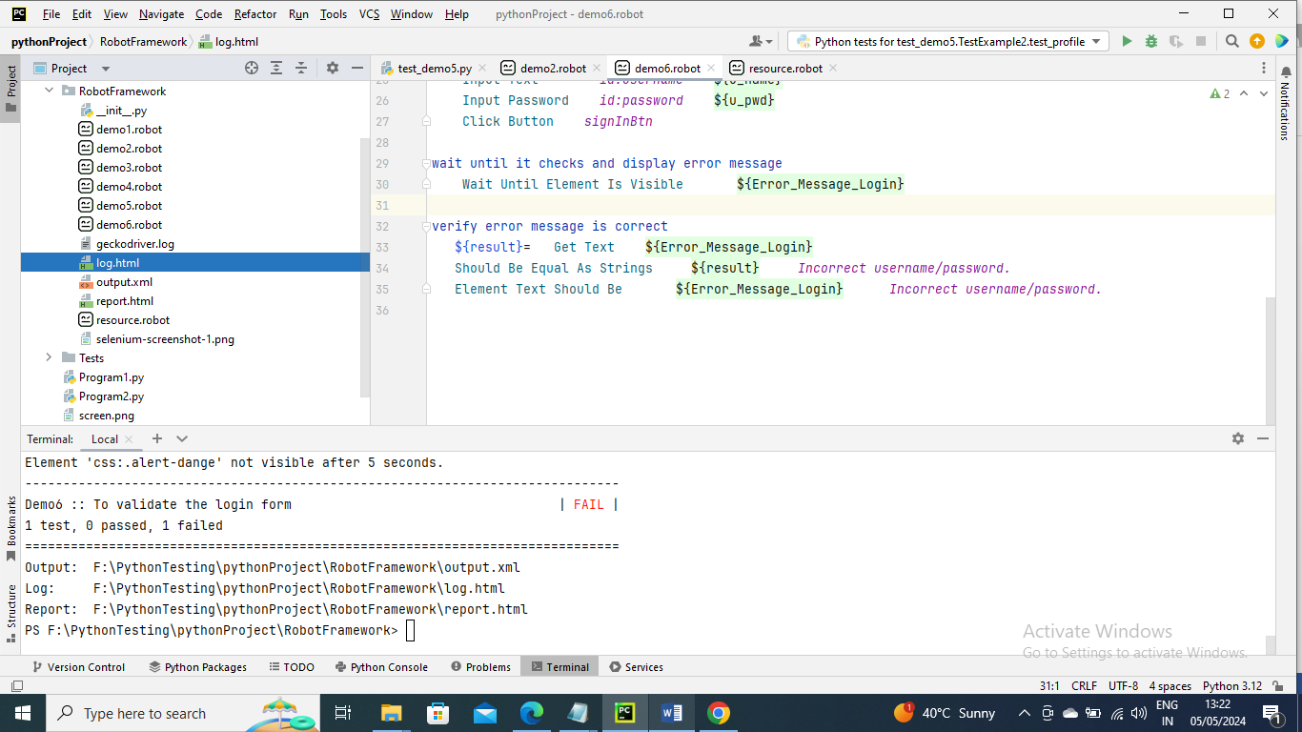

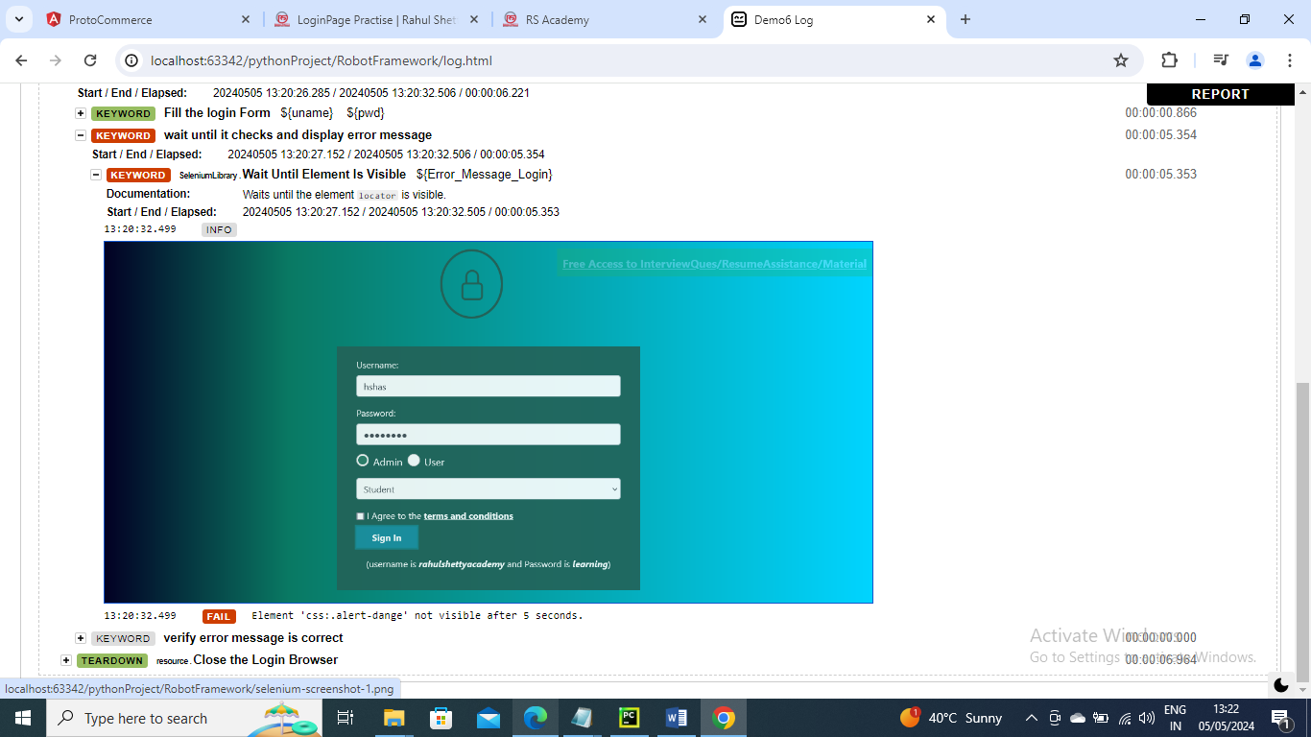

-----------------

Until now we had login data parameters or any parameters directly in program or resource program

But sometimes we want program to be generic and want to pass parameters using another file

First we need to install Library robotframework DataDriver

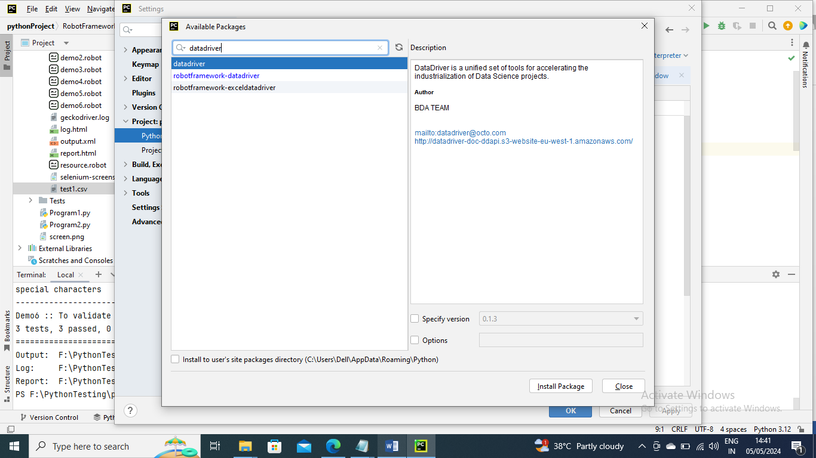

Below is an example where we are passing values to Login page from csv if we need add further credentials directly in csv without changing program

Below resource is not changed

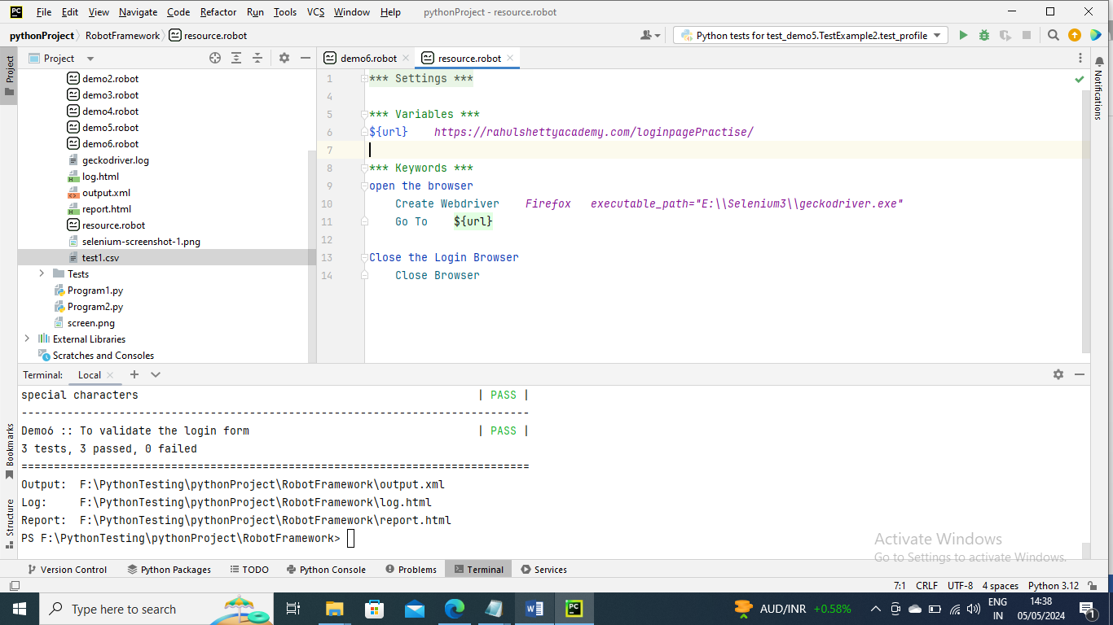

Below is the csv with login credentials info

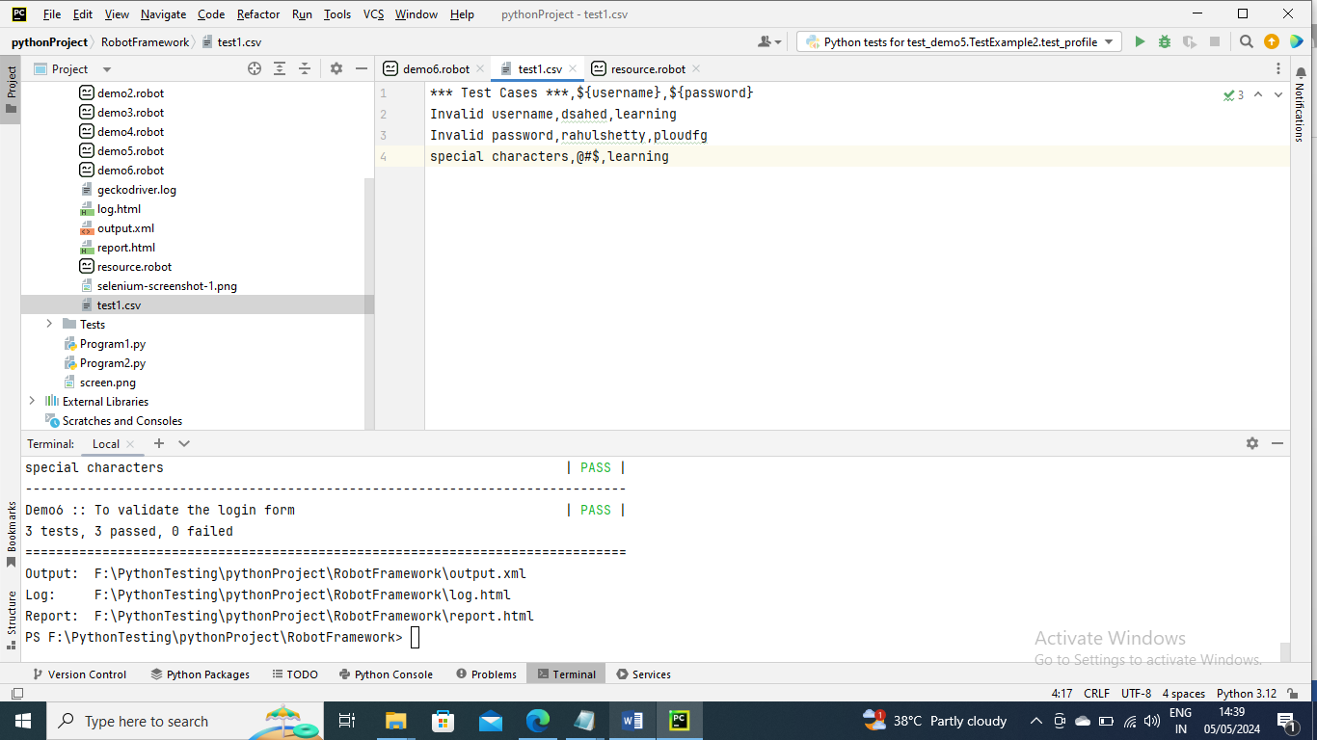

Below is the main program here you need mention Library datadriver and parameters of specific location of csv and encoding and dialect

For example - Library DataDriver file=test1.csv encoding=utf_8 dialect=unix

Also the field names and arugemts names should be same for example csv field name is ${username} and {password} so in program the aruguemnts name must be same

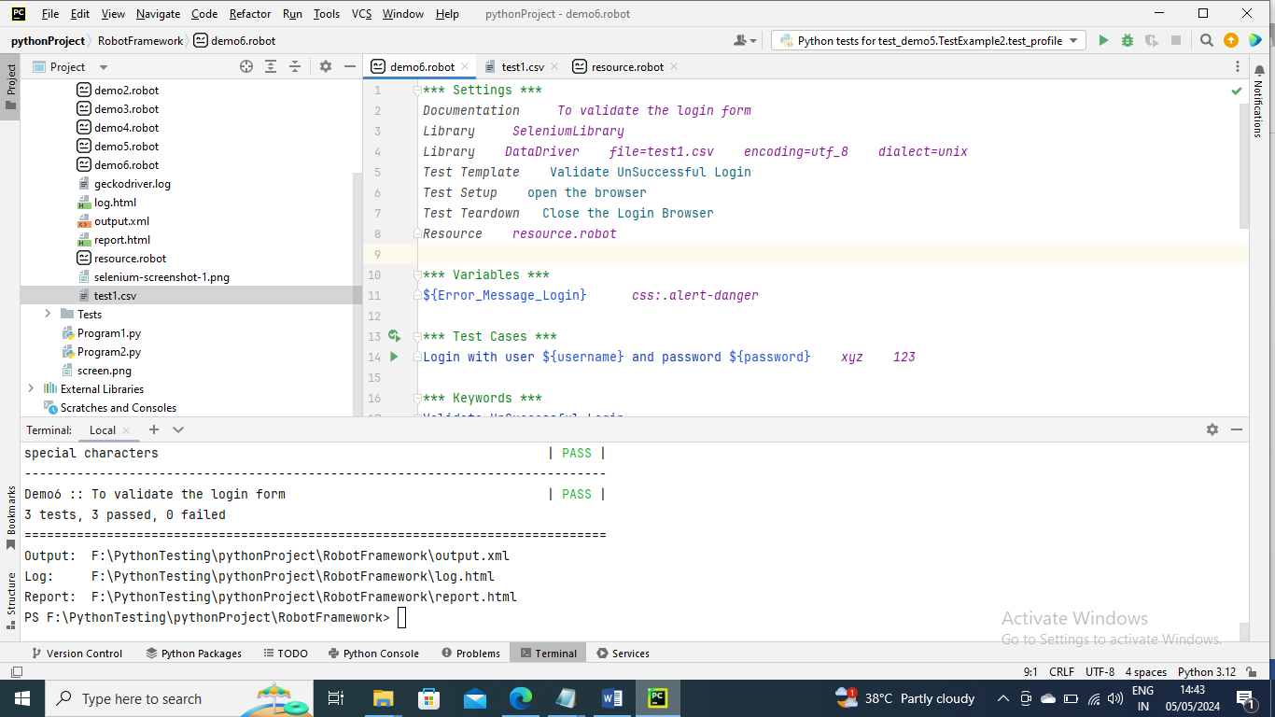

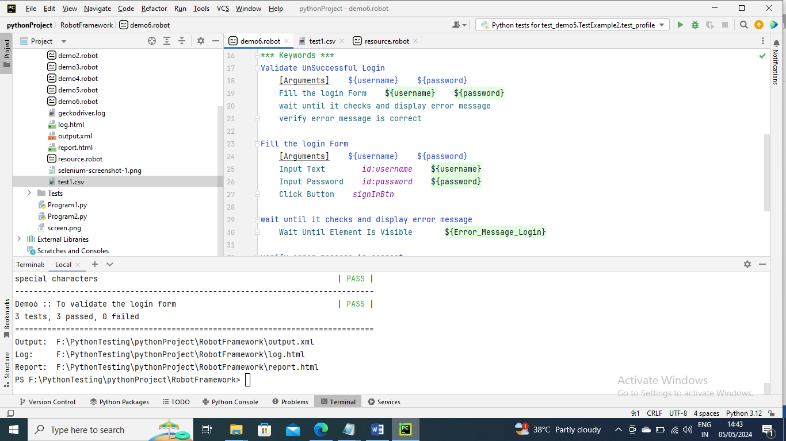

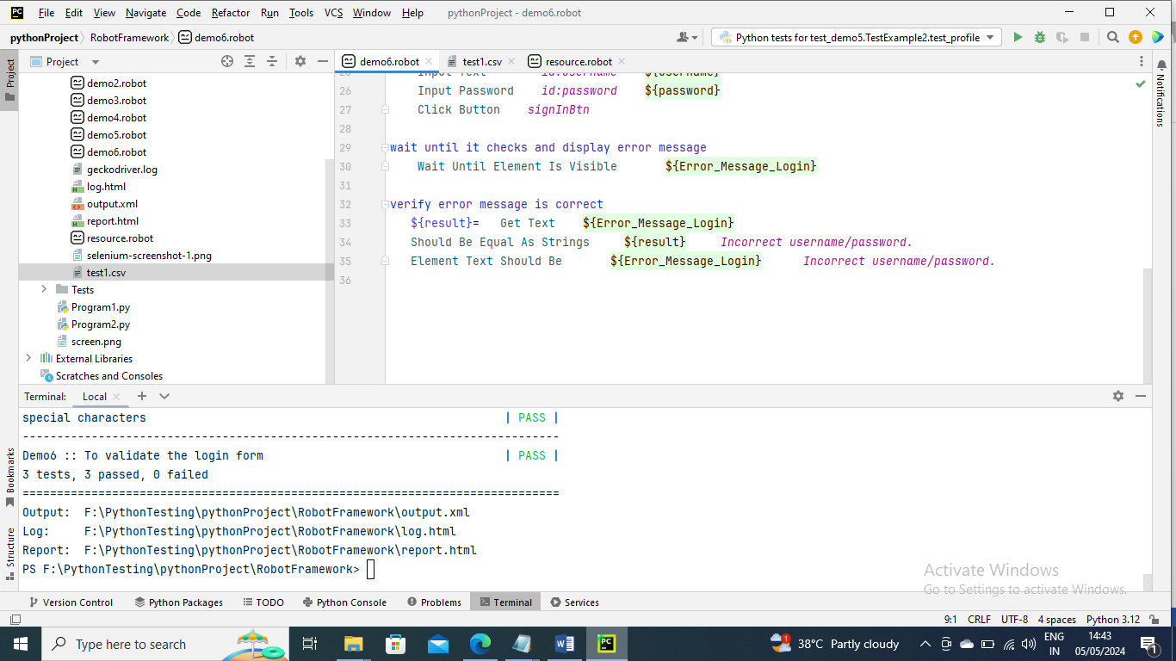

Now run the command to see output and you can see below 3 tests are executed and passed

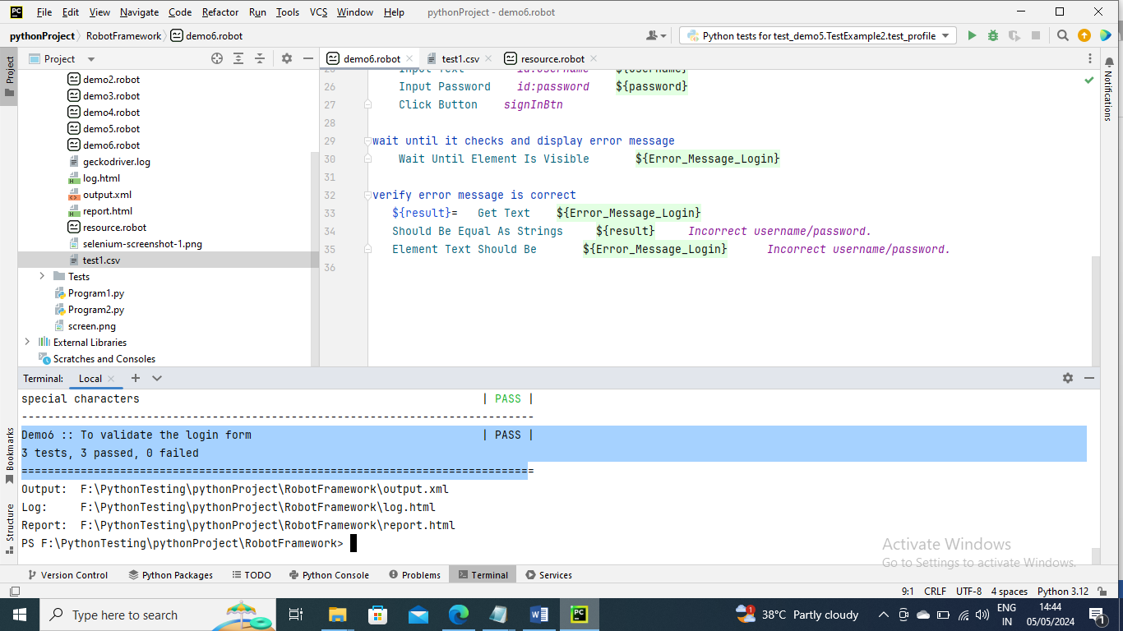

---------------------

Below is an example where you using robot framework syntax is more complex then you can create your own custom keyword using python programming .py extension and import that library and use that keyword

In below I have created an keyword where it adds the ietems that sent in parameter and checkout

Below is resource program

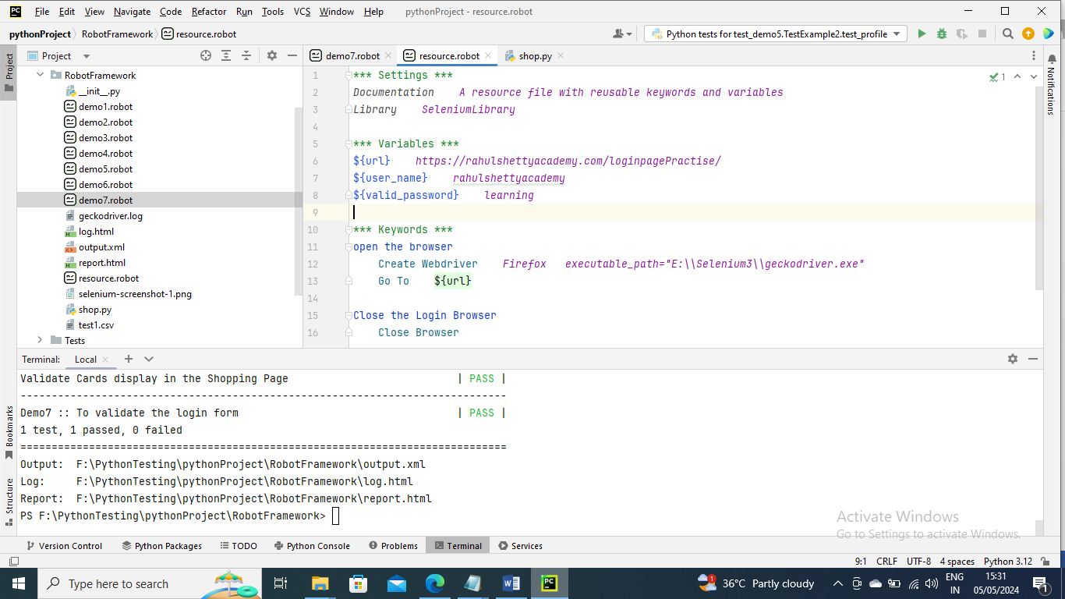

Below is the custom keyword I have created where it adds to cart of products sent in parameter and later checkouts

The below constructor code(below) is written so that you can get all the characteristics of Selenium Library

self.selLib = BuiltIn().get_library_instance("SeleniumLibrary")

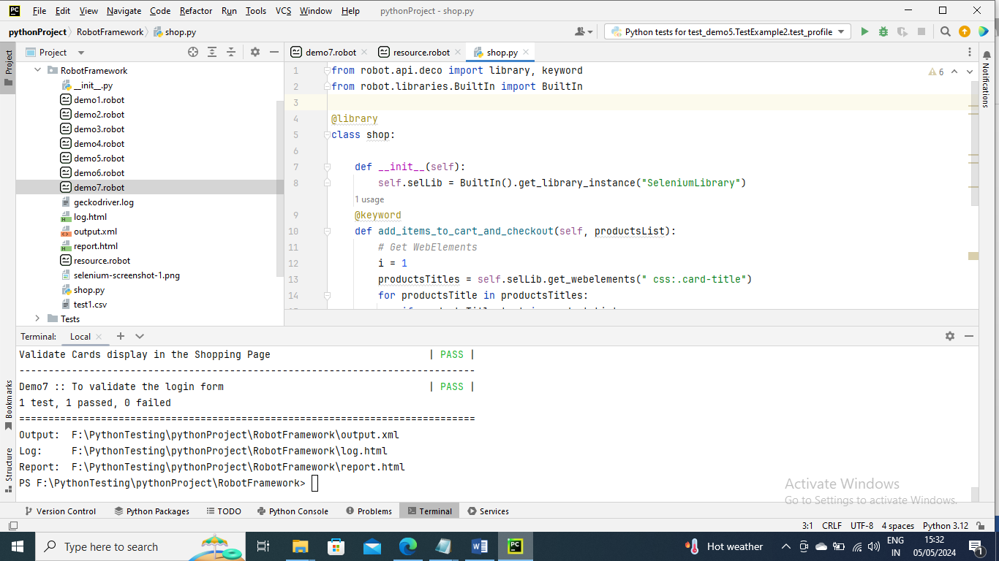

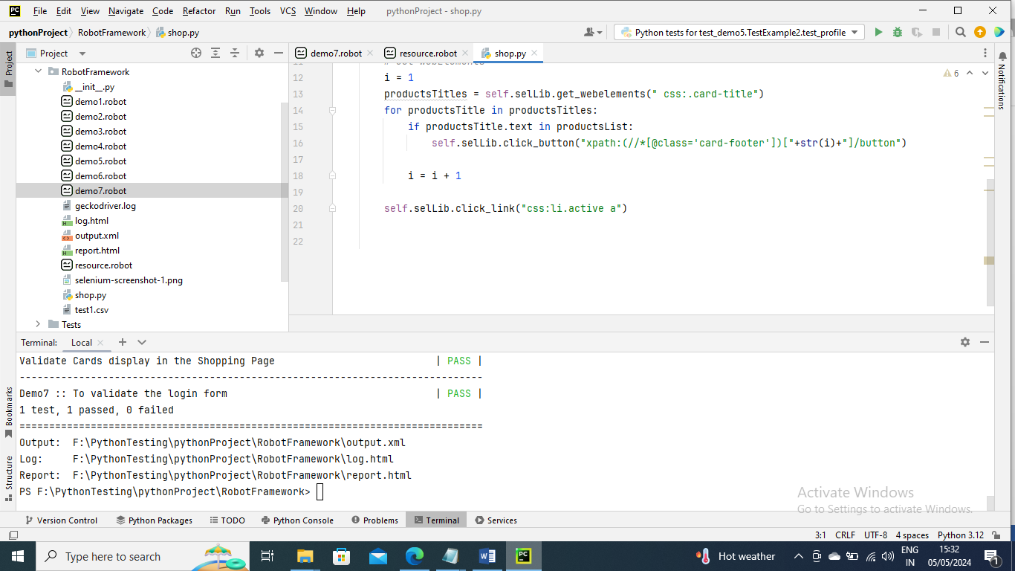

Below is the main program where you provide python keyword program in library so that you can import its keyword and you can call that method and pass parameters

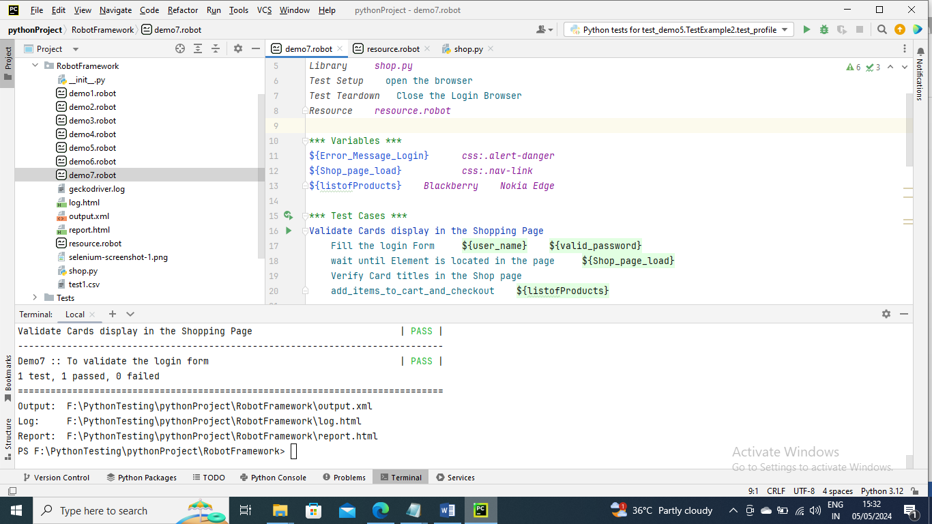

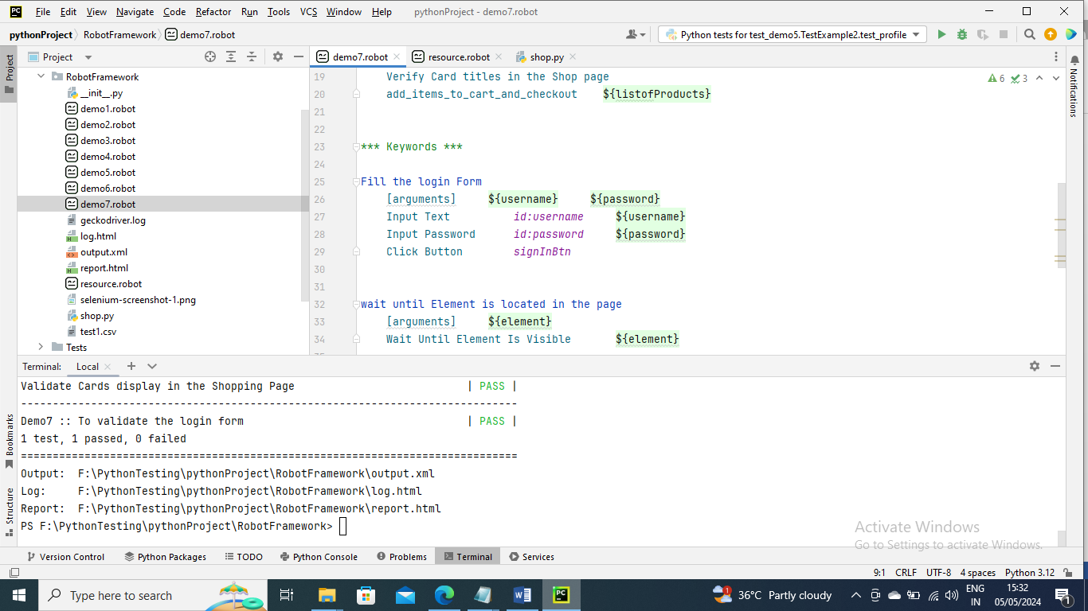

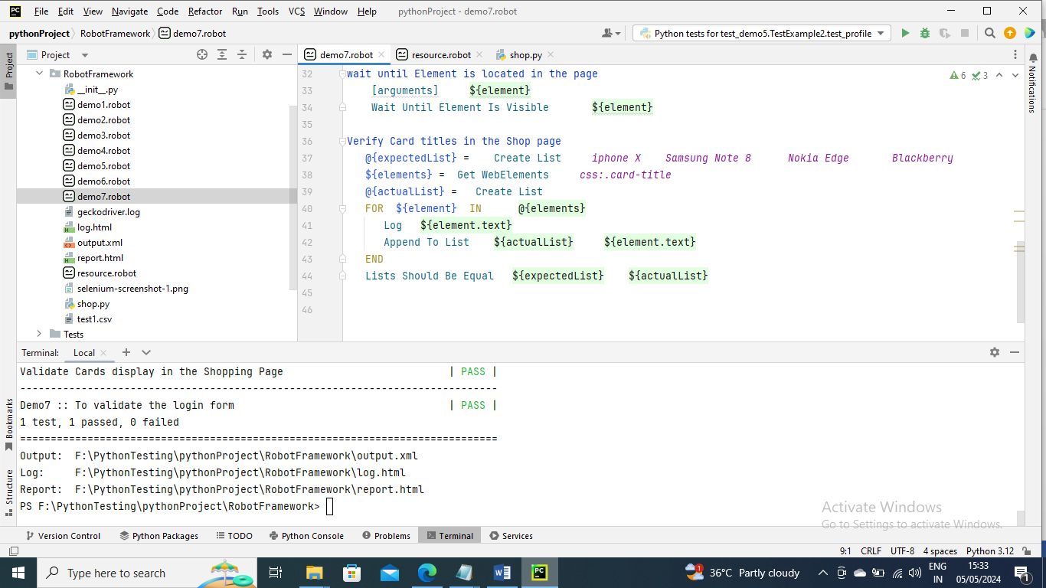

Run the command for output as usual

-------------------------------------

Running Tests

If you want to execute all the program test cases say demo1,demo2 and ……in apackage or in Project (say RobotFrame package or PythonProject) …you can do it by executing

Syntax --- robot .

-------------------

If you want to run test programs inside a package or project parallel we can’t do it directly using Robot Framework ….we need to install third party plugin called pabot

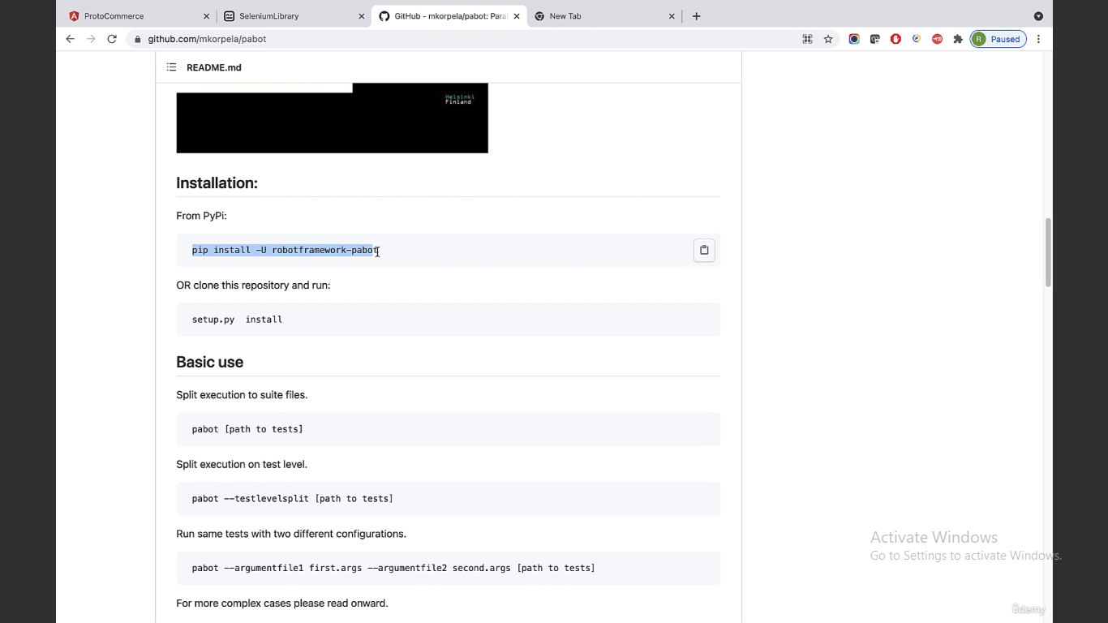

Running the script to install

Pip install –U robotframework-pabot

Now run the command to execute parallel runs

Syntax ---- pabot .

-----------------

If you want to run test cases inside a program in parallel use below command

Syntax ----- pabot - -testlevelsplit testdemo6.robot

-----------------

Below are the commands to execute test cases in program or in general

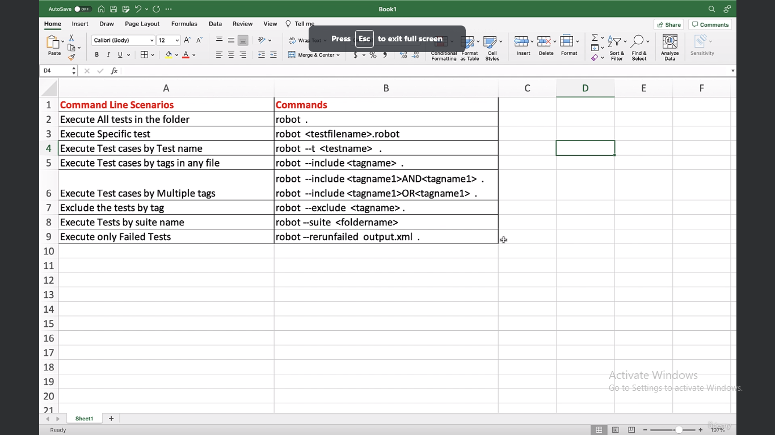

------------------

Below is command to execute a specific test case from a program

Syntax ----- robot –t “Open the Browser” demo1.robot

If you wants to execute wherever this test case name is present in total project you can give below

Syntax ----- robot –t “Open the Browser” .

If you want to execute test case where the name contains related you can do below

In below any test case that starts with Open will be executed

Syntax ----- robot –t “Open*” .

-----------------------

Let’s se you have certain test cases that needs to be executed every one hour let’s say then you can mark it with any tag name and run it so that only that gets executed

For example I have tagged below test case with SMOKE

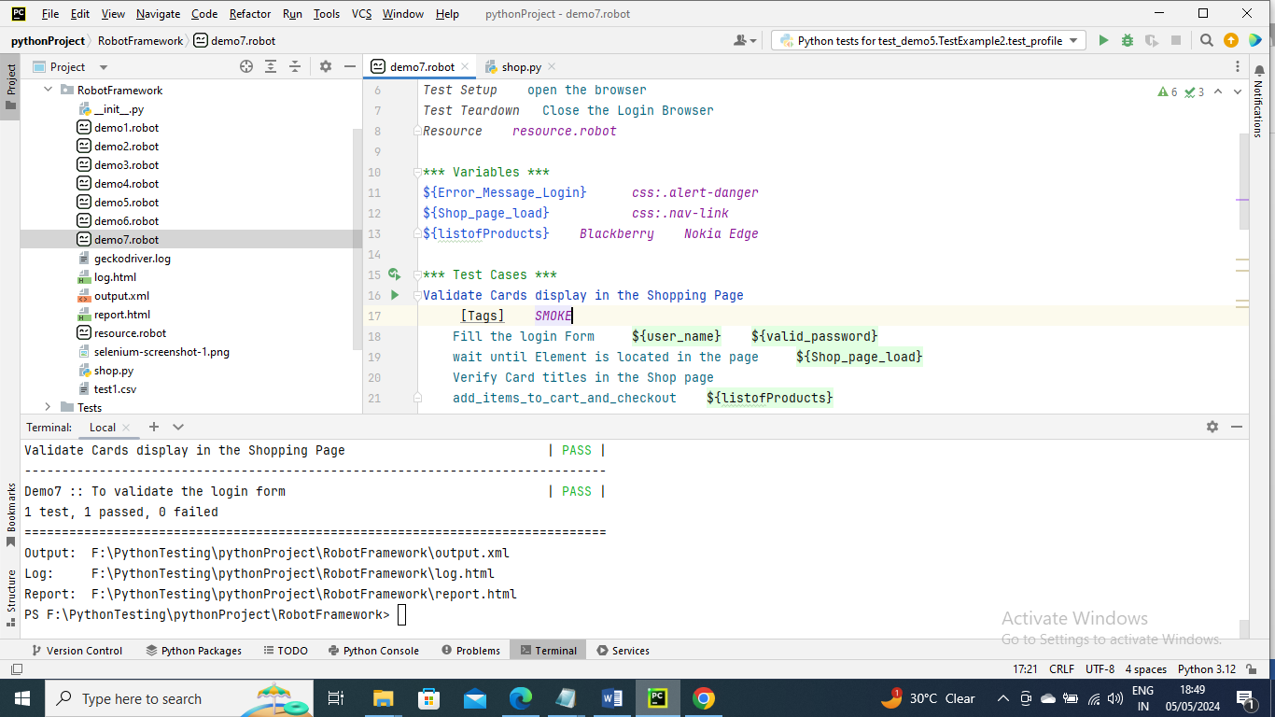

Now run the command below

Syntax--- robot - -include SMOKE .

It will check entire project and runs where the tag is SMOKE

-----------------

I have marked on test case as REGRESSION which runs once in 2 days for example

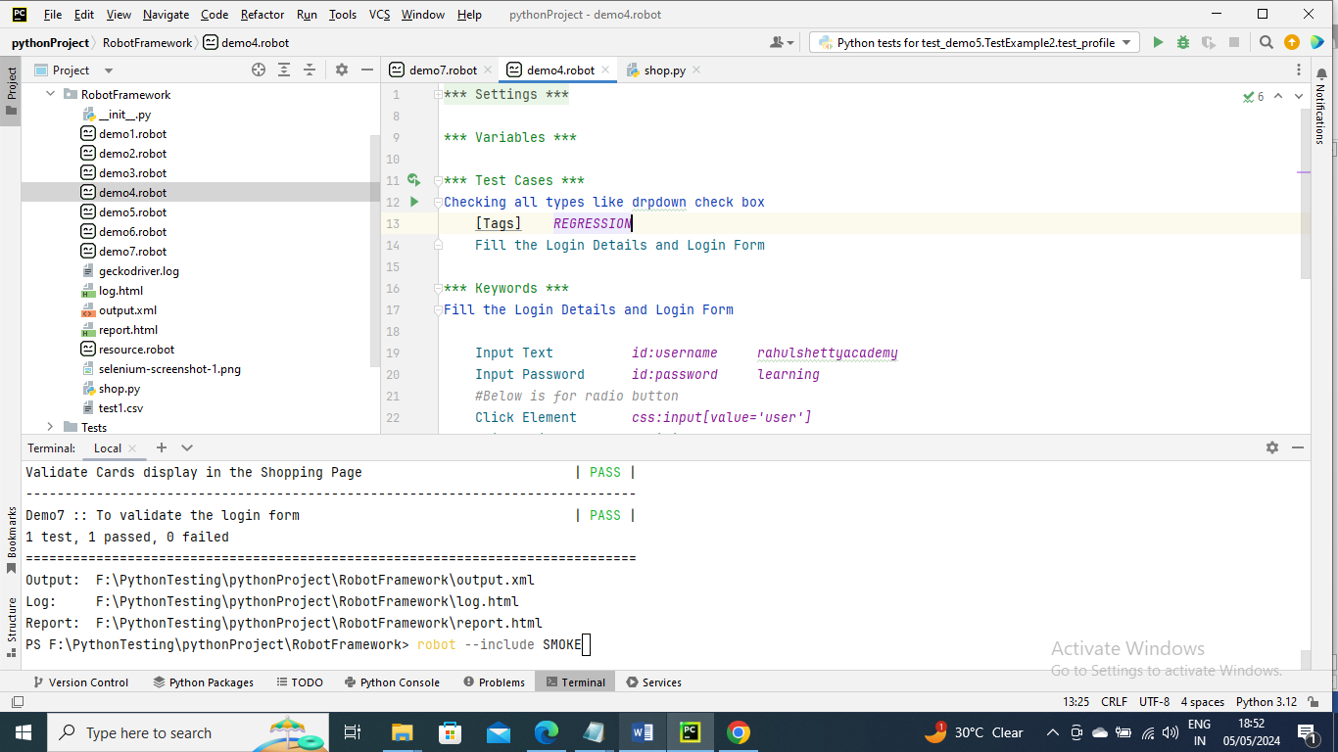

You can execute same like above

Syntax--- robot - -include REGRESSION .

-------------------------

There is a scenario where some test cases are tagged with SMOKE and some are tagged with REGRESSION and you want to run if it tagged with either of one you can give below

robot – include SMOKEORREGRESSION .

----------------------------

There is a scenario where some test cases are tagged with SMOKE and with REGRESSION for example you want to run if it tagged with both, you can give below

robot – include SMOKEANDREGRESSION .

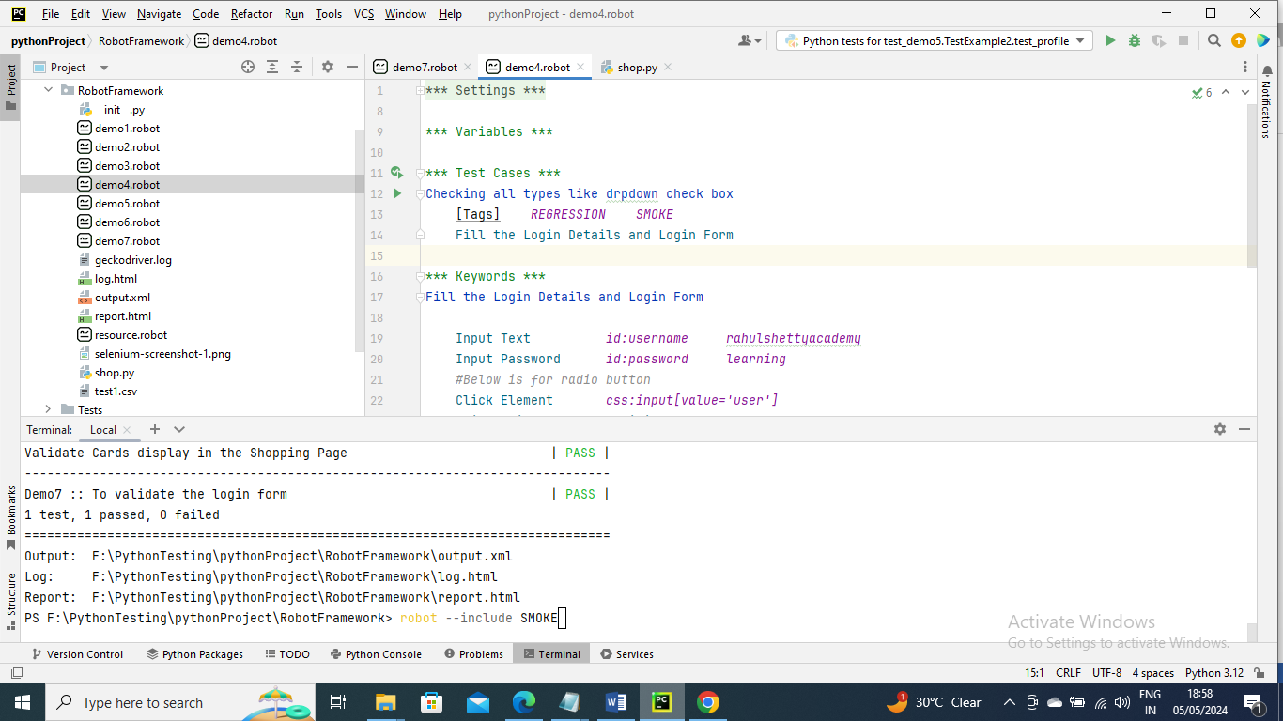

----------------------

If you want to exclude all the test cases with tag SMOKE you can do below

robot - - exclude SMOKE .

if you wanted to re-run the failed test cases you can do below

robot - -rerunfailed output.xml demo6.robot

or ……robot - -rerunfailed output.xml .

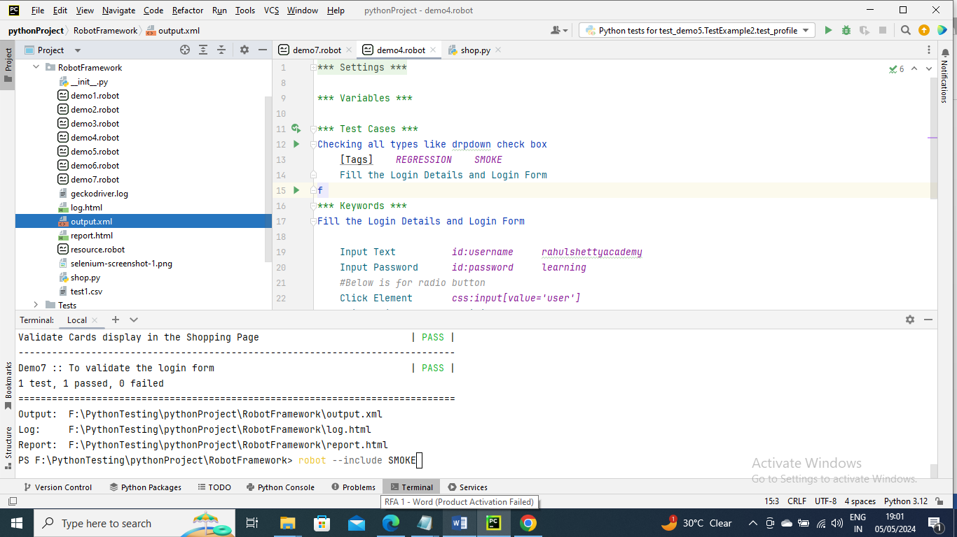

---------------

For example I want to change the user_name variable value for test run and but doesn’t want to change in program then I can give the command as below to pick the value given in command

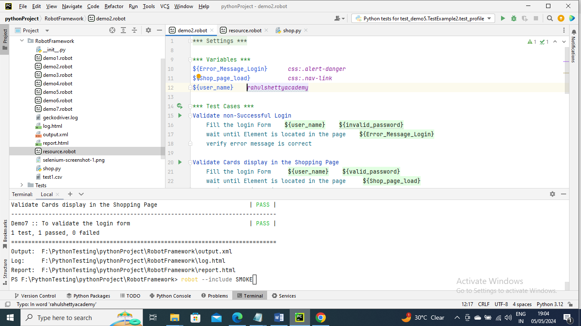

Syntax…………….robot –variabe user_name :ramu demo2.robot

------------

And if you want to run or smoke and changing its variable you can give below

Syntax…………….robot - -variabe user_name :ramu - -include SMOKE demo2.robot

----------------------

Below is an example on how to read, write and get the



